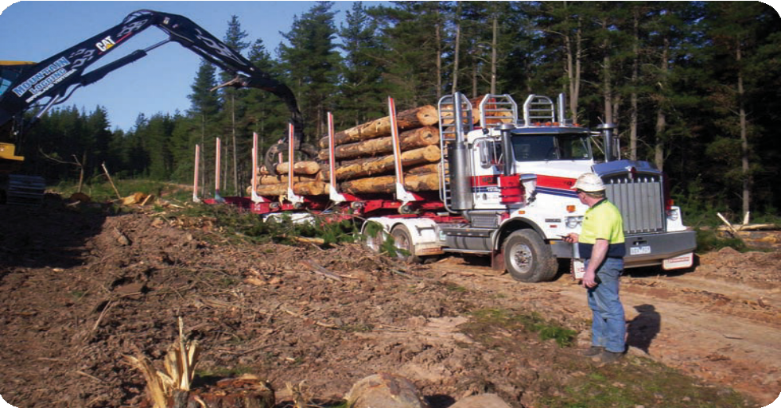

L
TECHNIQUES FOR LOADING, DRIVING AND UNLOADING TRUCKS
THAT CARRY LOGS AND OTHER FOREST PRODUCE

orestWorks ISC ersion 1, August 2014

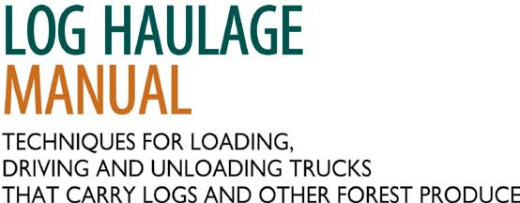

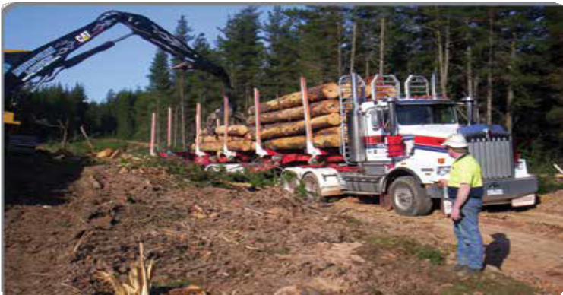

Version 1, August 2014

These materials were developed ForestWorks ISC in association with the Commonwealth Government through the Department of Industry.

Copyright Statement

© 2014 Commonwealth of Australia.

With the exception of the Commonwealth Coat of Arms, the Department’s logo, any material protected by a trade mark and where otherwise noted, all material presented in this document is provided under a Creative Commons Attribution-No Derivative Works 3.0 Australia licence.
You are free:
- to copy, distribute, display, and perform the work
- to make commercial use of the work

Under the following conditions:
- Attribution — You must give the original author credit
- No Derivative Works — You may not alter, transform, or build upon this work

Special Conditions (Waiver)
For the sake of clarity, where the licence refers to “the work”, in addition to meaning the work in its entirety this term shall also mean “extracts of the work”. Extracts of the work carry with it the respective licence, and is thus “partitioned”.

The details of the relevant licence conditions are available on the Creative Commons website (www.creativecommons.org.au) as is the full legal code.

Disclaimer
This work is the result of consultations with Australian industry participants. It is a collaborative view and does not necessarily represent the view of Department of Industry or any specific body. For the sake of brevity it may omit factors which could be pertinent in particular cases.

While care has been taken in the preparation of this material, Department of Industry and the original developer do not warrant that any licensing or registration requirements specified here are either complete or up-to-date for your State or Territory. Department of Industry and the original developer do not accept any liability for any damage or loss (including indirect and
consequential loss) incurred by any person as a result of relying on the information contained in this material.

The Commonwealth, through Department of Industry, does not accept any liability to any person for the information or advice (or the use of such information or advice) which is provided in this material or incorporated into it by reference. The information is provided on the basis that all persons accessing this material undertake responsibility for assessing the relevance and accuracy of its content. No liability is accepted for any information or services which may appear in any other format. No responsibility is taken for any information or services which may appear on any
linked websites.

ForestWorks ISC activities are assisted by funding provided by the Commonwealth Government through the Department of Industry.
Published by
ForestWorks ISC
559A Queensberry Street (PO Box 612) North Melbourne, Victoria 3051 Australia

Telephone: +61 3 9321 3500
Local call: 1800 177 001 (Australia only)
Fax: +61 3 9326 7800
Email: forestworks@forestworks.com.au Web site: www.forestworks.com.au

ABN 39 946 785 543
ACN 130 528 291

Illustrations by Engistics Pty Ltd
Front cover photo courtesy of PF Olsen (Aus) Pty Ltd Photos on pages 4 and 5 courtesy of PF Olsen (Aus) Pty Ltd All PPE images on pages 14 /15 sourced from Barry Barnes,
Shutterstock.com, except ‘Sun Protection’ image on page 15 courtesy of Engistics Pty Ltd.

Acknowledgements
ForestWorks would like to thank the following for their contributions to this manual:

Technical advisors:
David Bennett, PF Olsen (Aus) Pty Ltd Sean Carlson, Engistics Pty Ltd

Steering Committee:
John Love, HVP Plantations Marie Clegg, Midway Ltd
Ricky Leeson, Leesons Harvest and Haulage Charles Stansfield, VicForests
Bree Venturoni, Retreev Pty Ltd
Peter Grist, Australian Forest Products Association Jillian Roscoe, Victorian Association of Forest Industries
Travis Wacey, Construction, Forestry, Mining and Energy Union Andrew Nicholson, Great Southern Institute of Training, WA Neil Worrell, Albany Plantation Export Company
Jamie O’Neil, Forestry SA
Ian Laing, Forestry Corporation of NSW John Webb, Norske Skog
Sandra Heatherington, Norske Skog David Priem, NSW TAFE
Adam Farquharson, NSW TAFE David Millard, Parkside Group
Col McCulloch, Australian Forest Contractors Association Rod McInnes, Timber Queensland

Printed on Australian made and PEFC certified Precision paper. Promoting sustainable forest management in Australia and around the world.

Contents

- Introduction 1
Compliance with licensing and laws 1
Load restraint certification 2
- National competency standards 3
Drivers 3
Loading and unloading trucks 4
Other supply chain duty holders 4
- Professional approach 5
- Workplace safety 6
Responsibilities in the workplace 6
Risk management 8
Common hazards in forestry operations 11
Safe work areas 13
Understanding the operating limits of your machine 13
Personal protective equipment 13
Communications 16
Worksite inductions 17
Warning signs and safety documentation 18
Emergency plans and procedures 19
Significant workplace health and safety issues 19
Incident and hazard reporting 21
- Heavy Vehicle National Law 23
Chain of responsibility 23
Mass limits 25
Dimension limits 25
Fatigue 28
Load restraint 29
Load restraint systems 31
Why friction is important 32
Tie-down systems 33
- Caring for the environment 36
Codes of practice 36
Certification 36
Looking after roads and water quality 37
Dust 38
Noise 38
Rubbish 38
Incident reporting 38
- Maintenance and inspection 39
- Mobile plant 41
- Loading trucks 45
Life threatening hazards 45
Safe zone 46
Risks of loading logs 48
Landing conditions 49
Placing the load on the truck 50
Securing the load 54
Loading other forest produce 59
- Transporting logs 60
Life threatening hazards 60
Load stability and truck rollover 61
Working with other trucks on forest roads 63
- Unloading trucks 64
Life threatening hazards 64
Arriving at a site 64
Safe work areas 65
Unstrapping the load 66
Machine assisted unstrapping procedure 66
Unloading and stacking out 67
- Record keeping and paperwork 68
- Running a business 69
Orders and schedules 69
Performance monitoring 69
- Relevant authorities and legislation 70
Workplace safety 70
Heavy Vehicle National Law 71
Environment 72
- Technical standards and further references 73
- Glossary 74
- Emergency plans 77
Motor vehicle incident 78
Loss of log on public road 79
First aid procedure 80
Unauthorised persons entering a worksite 81
Fire 82
Spills of fuels or oils 83

Log loading and haulage is a high risk activity. Many fatalities and serious injuries have occurred as a result of drivers being struck by falling logs. Most of these accidents are caused by incorrect and unsafe loading or unloading techniques and drivers not knowing about or following safe work procedures.

- Introduction

This manual is designed primarily for use by workers in forest coupes, plantations, and log yards, but is also a valuable reference for people involved with planning and supervising haulage operations. The scope of the manual is designed to include all activities related to moving forest produce from a landing or roadside dump in the forest to a wood yard at a processing or export facility. As many of the incidents involve two or more workers working together, the manual looks at the different roles involved in the log transport process and highlights critical work practices with the aim of reducing the likelihood of fatalities and serious injuries.

The manual also provides a brief overview of the requirements of Heavy Vehicle National Law and provides practical information to help drivers understand their obligations under regulations dealing with fatigue, mass and dimensions, and load restraint.

Compliance with licensing and laws
Drivers are all required to be licensed to drive their vehicle on public roads. Loaders may also be required to hold a high risk work licence by a workplace authority to operate a crane. In some states, forest workers are required to carry a licence to work in a forest environment. Please contact the relevant state authority listed in Section 14 for current requirements.

This document does not have any standing under any of the legislation discussed in the following sections. It is a description of best industry practice at the time of writing and provides practical guidance about the steps drivers need to take to ensure they meet the requirements of performance standards prescribed by the Heavy Vehicle National Law.

To assist in understanding the meaning of laws, the following words will be used throughout the documents as follows:
- ‘must’ is used where there is a clear legislative requirement,
- ‘should’ is used where there is a generally accepted industry practice to address a particular issue, and
- ‘may’ is used where there are a number of valid alternatives to address a particular issue.

In addition to using standard language the document uses ‘traffic light’ tables that alert you to preferred solutions to manage the risk.

- Green is used where a solution is preferred because it is clearly a lower risk.
- Orange is used for a reduced risk solution which may be used as an interim arrangement or if the preferred solution is assessed as not reasonably practicable in an individual situation.
- Red is used to highlight practices that do not adequately reduce a risk.

Load restraint certification
Engistics Pty Ltd developed the methods outlined in Restraining short logs and Restraining long logs on pages 56 and 57 of this document to allow compliance to the performance standard as nominated on page 186 of the Load Restraint Guide. These methods are appropriate for log loads that meet all the criteria listed above each table. It remains the responsibility of the user to ensure that the methods are adequate for a particular situation. Additional load restraint may be necessary under some conditions.

The information in this manual should be used to support training aligned to units of competency from the Forest and Forest Products Industry Training Package. For information and advice on learning and skills development please contact ForestWorks ISC, the national skills advisory body for the forest, wood, paper and timber products industries.

- National competency standards

National competency standards specify the skill and knowledge requirements for performing particular tasks or job functions in the workplace to the standard expected in the industry. They may be packaged into a skill set. A skill set is a combination of units of competency that reflect a job role or a specific industry need. Units of competency can be downloaded from www.training.gov.au.

Please note that reading this manual does not constitute competence in these units. Truck drivers seeking assessment in any of the units below should consult a Registered Training Organisation (RTO). A list of RTOs can be found on the ForestWorks ISC website (www.forestworks.com.au).

It is recommended that drivers and loaders hold the following units of competency in addition to any regulated vehicle or high risk work licences.

Drivers
The units of competency within the skills sets listed below are wholly covered by this manual.

Skill set | Skill set
Skill set for a forestry log truck driver (FPISS00027) | Skill set for a forestry produce truck driver (FPISS00028)
Units of competency | Units of competency
FPICOT3261 Transport forestry logs using trucks | FPICOT3262 Transport forest produce using trucks
FPICOR2205B Follow OHS policies and procedures
FPICOR2203B Follow environmental care procedures

Loading and unloading trucks
Units of competency related to loading and unloading trucks are listed below. The material in this document is relevant underpinning knowledge for these units but is not intended to address all of these units.
- FPIHAR3206C Conduct forwarder operations.
- FPIHAR3218A Conduct loader operations.
- FPIHAR3219A Conduct excavator operations with grabs.
- TLID3011A Conduct specialised forklift operations.
- FPICOR2205B Follow OHS policies and procedures.
- FPICOR2203B Follow environmental care procedures.
- HLTFA311A Apply first aid.

Other supply chain duty holders
Other people in the supply chain hold legislated duties. The Forest and Forest Products Industry Training Package includes some relevant competency standards for these people. The material in this manual is likely to be useful background information but is not designed to fully satisfy the technical knowledge necessary to satisfy these units.

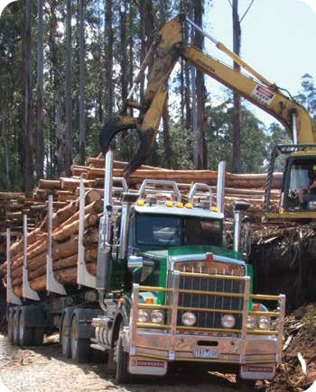

It is essential that drivers and loaders maintain a professional and responsible attitude towards all aspects of loading, driving and unloading trucks carrying logs and other forest produce.

- Professional approach

Log trucks, in particular, are the public face of the timber industry. In order to ensure our industry is a sustainable industry, it is important that logs are hauled in a manner that:
- does not place workers or members of the public at risk,
- does not cause damage to roads,
- does not damage the natural environment,
- does not cause concern to affected local communities, and
- minimises the costs associated with delivering logs, and forest produce.

Attributes that make a competent driver or loader include:
- putting safety first,
- careful planning and risk assessment,
- good problem solving skills,
- maintaining a steady work pace without rushing,
- communicating clearly and respectfully with other workers and supervisors,
- using sound, low-risk techniques,
- thinking about ways to make the job safer and more efficient,
- understanding and taking care of equipment,
- caring about the environment, and
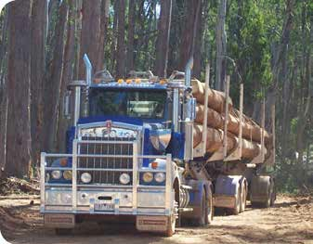
- keeping good records.

Competent drivers and loaders are people who can:
- work cooperatively to ensure they look after each other’s health and well-being,
- apply correct work techniques,
- recognise when it is necessary to ask for assistance to avoid a hazardous situation.
- read and obey signs, and
- follow site rules and procedures.

All states and territories in Australia have laws that aim to:

- Workplace safety
- ensure the health, safety and welfare of workers,
- protect the public from the health and safety risks of business activities,
- eliminate workplace risks at the source, and
- ensure the involvement of workers in the development and implementation of health, safety and welfare standards.

The following principles should be applied in order to comply with these laws.
- All people are given the highest level of health and safety protection that is reasonably practicable.
- Those who manage or control activities that give rise, or may give rise, to risks to health or safety are responsible for eliminating or reducing health and safety risks, so far as is reasonably practicable.
- Employers or self-employed people should be proactive and take reasonably practicable
measures to ensure health and safety in their business activities.
- Employers and workers should exchange information about risks to health or safety and measures that can be taken to eliminate or reduce those risks.
- Workers are entitled, and should be encouraged, to be represented on health and safety issues.

These laws are enforced by state authorities with expertise in health and safety matters. Refer to Section 14 to find the relevant authority in your state or territory.

Responsibilities in the workplace
When you are at work you must:
- take reasonable care of your own safety,
- take care of the safety of others who may be affected by what you do or fail to do,
- cooperate with any actions taken by your employer to comply with health and safety laws,
- never intentionally or recklessly interfere or misuse anything provided at your workplace in the interests or health, safety and welfare, and
- report hazards and incidents.

In practice, this means you should:
- follow all reasonable directions of your employers and people in charge of your workplace. These directions may take the form of signs, operating procedures, site inductions or user manuals for the truck or machine you are using,
- speak up and question any rules or directions that don’t make sense or may make a problem worse,
- not interfere or alter safety features of the truck or machine you are operating. These include:
  - guards including windows,
  - warning devices,
  - seat belts,
  - isolation devices,
  - emergency equipment like first aid kits and fire extinguishers,
  - operating manuals and safety documentation,
  - decals and signs, and
- use all the safety equipment you have been supplied, including personal protective equipment.
Remember, safety laws recognise that workers may not be able to eliminate or reduce health and safety risks on their own. The following table outlines other people who may have control over activities in your workplace and the types of things they can do to make your job easier and safer.
If you have a problem with the way a job is planned or specified, make sure you tell someone about your concerns. It is important to remember that more than one person may have a workplace health and safety responsibility, so by raising a problem, you are helping them do their job.
The table below shows a summary of the other duty holders involved in log haulage and their responsibilities.

Duty holder | Things they can do to make your job safer
Controllers or managers of a workplace
Government agencies, or private persons who control or own the land on which work is conducted | - Ensure roads are appropriately built and maintained  - Provide information on known hazards
Persons conducting a business or undertaking, or employer
Forest managers (Coupe supervisors) | - Engage competent contractors and staff  - Select the safest technique for transporting logs or forest produce  - Ensure trucks match products  - Enable safe access to loading and unloading areas  - Liaise with road authorities about road conditions  - Pass on information about known hazards  - Ensure work can be conducted safely in the available time  - Establish emergency procedures  - Ensure there is enough space in loading areas for safe loading  - Develop traffic management plans  - Facilitate communication between contractors in the workplace  - Monitor and supervise contractors to ensure safe systems of work

Duty holder | Things they can do to make your job safer
Persons conducting a business or undertaking, or employer
Harvesting contractors | - Provide suitable plant for loading logs or forest produce  - Ensure landings have enough space for storing logs and safe loading  - Ensure loaders are competent  - Maintain safe loading zone  - Ensure log stacks are safe  - Supply facilities for extended rest breaks
Haulage contractors | - Provide suitable trucks, trailers and load restraint devices  - Ensure drivers are competent  - Ensure loading and unloading areas are safe  - Ensure drivers are provided with appropriate safety information at loading and unloading facilities  - Develop and maintain written work procedures in consultation with workers  - Supervise work practices  - Ensure workers have and use personal protective equipment  - Establish and maintain consultation arrangements  - Ensure emergency plans and equipment are available and effective
Log yard managers | - Ensure truck drivers are aware of site protocol  - Check loads for compliance with Heavy Vehicle National Laws and quality requirements  - Provide suitable plant for unloading logs or forest produce  - Ensure loaders are competent  - Maintain safe unloading zone  - Minimise turn-around times  - Ensure facilities are adequate for meals and extended rest breaks
Designers, manufacturers and suppliers | - Supply safe trucks and trailers with functions or devices that help to reduce risks  - Supply safe loading and unloading machines with functions or devices that help to reduce risks  - Supply information about how to safely use the materials or equipment they have supplied, for example operator’s manuals or safety data sheets

Risk management
Risk management is intended to be an opportunity to improve a job. If done properly, most risk assessments result in a change to the way a job is done, and make it easier and safer to do.
Risk management involves four steps:
- identify hazards – find out what could cause harm.
- assess risks – understand the nature of the harm that could be caused by the hazard, how serious the harm could be and the likelihood of it happening.
- control risks – implement the most effective control measure that is reasonably practicable in the circumstances.
- review control measures to ensure they are working as planned.

Unless there are already well-known and effective controls in use in your workplace, you should be involved in a risk assessment when:
  - you start working on a new site,
  - you start working in a new or modified truck or machine,
  - something goes wrong and someone is hurt or nearly hurt, or
  - you change the type of logs you are carting.

It is true that hazard identification sometimes brings up ‘hard-to-fix’ issues. Some things ARE hard to fix. Nevertheless, do not be afraid to write things down on a list of hazards. If you write a hazard down, a new way of addressing the hazard may be identified, but one thing is for certain – if you don’t write it down then nothing will happen.

When you are involved in finding ways to control or reduce risks you should use the hierarchy of risk control. This involves trying to use controls with higher levels of protection and reliability. Risk controls are ranked as follows.
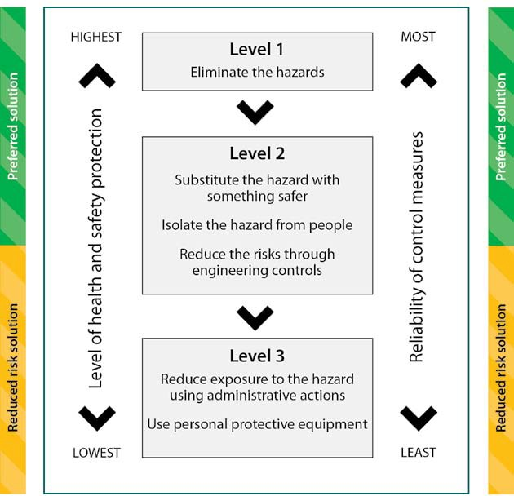
The hierarchy of risk control (adopted from p.14 of Safe Work Australia’s “How to Manage Work Health and Safety Risks” – Code of Practice, 7/12/2011)

In general, for more serious risks, solutions should be selected from further up the hierarchy of control. Also, more serious risks need to be brought to the attention of people with the authority to make the necessary changes.

Your judgement and experience is an important part of risk management. If you are worried about what you are being asked to do then do not be afraid to speak up.

The following table is a practical example of risk management for log haulage.
Hazard | Log falls off truck onto public road
Risk assessment | Potential nature of harm | Causes a member of the public to have a motor vehicle accident
 | How serious? | Possible multiple deaths
 | How likely? | Logs of all shapes and sizes are reported falling from trucks
Possible controls | Level 1
 | Eliminate the hazard | Do not cart logs on road, or chip logs, infield
 | Level 2
 | Substitute the hazardous activity with a safer activity | Cart longer length logs that have sufficient overhang to ensure they do not fall off with sudden braking
 | Isolate the hazard from people | Not practical
 | Reduce the risk through engineering controls | Redesign load restraint systems to stop logs falling off
 | Level 3
 | Reduce exposure to the hazard through administrative actions | Possible preventative actions:  - Only cart logs after they have been in the bush long enough for sap to dry out  - Stop frequently to check that lashings are secure  - Increase frequency of inspections to ensure loads are crowned
 | Use personal protective equipment | Install cab guard on truck

Common hazards in forestry operations
Hazards can be important for different reasons. Some may cause a direct threat to you or other people while others may contribute to a more dangerous work environment. The following table highlights some common hazards in haulage operations. Each of the following sections will provide more information about hazards that are life threatening and the recommended techniques to manage them.

Hazards likely to injure you

These hazards have caused serious injuries in our industry:
  - branches or trees falling,
  - logs rolling or falling from log stacks and trucks,
  - workers falling from machine, truck or log stack,
  - workers being cut by a chainsaw,
  - workers being struck by a machine,
  - workers lifting heavy objects,
  - workers twisting and lifting at the same time, and
  - workers slipping or tripping.

What hazards may damage my health?
Sometimes the impact of a hazard is not apparent immediately. However, things you are exposed to at work may have long-term impacts on your health. These include:

Hazard | Control
Exposure to sunlight leading to increased risk of sun cancer | - Use recommended personal protective equipment
Exposure to, and handling, fuels or oils | - Keep fuels and oils in labelled containers  - Use pumps and other mechanical aids to transfer fuels and oils directly into machines  - Use recommended personal protective equipment
Exposure to whole body vibration | - Ensure seats are in good condition and well sprung  - Ensure machine suspension is well adjusted
Exposure to hazardous levels of noise  If you have to raise your voice to talk in your truck or your machine you should wear hearing protection | - Wear recommended hearing protection  - Keep radios in the cabs of trucks or machines to volumes where conversations can still be heard

Other hazards that increase the risk of injury

Some other hazards will not cause an injury but they may increase the chance that you will be injured because they reduce your ability to concentrate or they make it harder to recognise other hazards. These include:

Hazard | Control
Drinking alcohol | - Comply with road laws
Using medications or illicit drugs | - Comply with laws  - Inform your manager if you are on any medication that may affect your work. Stay home if necessary  - Tell your doctor what you do for a living before receiving any medication  - Inform your manager or crew of any long-term medication for a health complaint in case you are involved in an emergency at work
Being stressed | - Get enough sleep  - Eat a balanced, healthy diet  - Drink fewer caffeinated and high sugar drinks  - Exercise regularly  - Allow time-out for yourself  - Try to plan as much of the day as possible  - Talk to your workmates or family – don’t bottle things up  - Be prepared to wait – have a book or magazine to read
Not drinking enough water | - Drink fluids regularly  - Drink before feeling thirsty  - Avoid drinking fluids like soft drinks and cordials that have more than 8% carbohydrate content  - Drink plenty of water at night to recharge the body  - Drink a couple of glasses of water before leaving for work
Poor nutrition | - Start each day with a high-carbohydrate breakfast like cereal or toast  - Eat high protein foods like lean meat, chicken, eggs, milk and cheese at night  - Eat at the start of breaks to allow time for rest and to aid digestion
Tiredness or lack of sleep | - Build short, frequent rest breaks into your work routine  - Take at least two evenly spaced 30 minute rest breaks during the working day  - Refer to page 28 for details on driving hours
Working alone | - Check you have a means of getting help in an emergency (mobile phone or satellite enabled communication device)  - Arrange for regular contact with someone who can provide help in an emergency  - Ensure that person knows your location and intended route
Working at night | - Wear high visibility day–night rated garment/s  - Ensure there is adequate lighting  - The entire side of the truck and the top of the stanchions should be visible.  - It should be possible to walk around the site without tripping or falling over unseen objects  - The safe position during loading and unloading operations should be lit and visible to other machine operators (e.g. using reflective tape, marker or flashing lights)  - Log stacks should be visible when placing and removing logs

Safe work areas
In forestry operations, the risk of death or serious injury increases significantly when workers are not effectively separated from the known hazards of mobile plant and logs. Maintaining separation between you and other workers is the most basic safety measure when working in haulage operations.
Separation can be achieved in the following ways:
  - a physical barrier like a cabin or parked machine,
  - distance, or
  - time.
Sections 9 and 11 provide specific example of safe work areas during loading and unloading operations.

Understanding the operating limits of your machine
Operating machinery beyond its designed operating limits can create significant hazards such as truck and trailer instability. You should know and understand the limitations of the trucks and machines you drive and operate.
Before you start operating ask the following types of questions.
  - What length of logs can I safely handle with this truck or machine?
  - How high should logs be stacked on this trailer?
  - How far will logs slip if I have to stop suddenly?
  - How much free board should I leave in my chip bin?
  - Is there anything unusual about the way this truck handles?
  - Are there any other reasons why I cannot load to the maximum legal dimensions and weight limits?
It is much better to make sure you operate machinery within its operating limits rather than try to fix a problem after something has happened.

Personal protective equipment

What is PPE?
PPE is an abbreviation for Personal Protective Equipment. These are things that you can wear to reduce the chance of a serious injury. The law encourages hazards to be managed in a way that reduces the need to wear PPE, e.g. using a quieter machine rather than wearing hearing protection.

What PPE must be worn?
Your employer will specify what PPE is required to undertake a particular task.
When outside the cabin of a truck or machine, people working in haulage operations are expected to wear:
  - a safety helmet,
  - high visibility clothing, and
  - safety footwear.
You may need to wear eye protection or ear protection on some sites. When you handle lashings or refuel you should wear safety gloves.

Recommended PPE

Safety Helmets
Relevant Australian Standard AS/NZS 1801:1997

High Visibility Clothing
Relevant Australian Standard AS/NZS 4062:1999

Safety Footwear
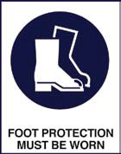
Relevant Australian Standard AS/NZS 2210:1994

- Do not write or stick anything on the shell of the helmet.
- The helmet should be replaced every two years or sooner if damaged.
- The date your safety helmet was issued to you should be written inside your helmet on the sticker supplied.

- High visibility clothing should be worn as the outer most garment at all times.
- When working in dull or dark conditions you should wear a retro- reflective garment. To be compliant with the Australian standard they must have the letter ‘N’ on their label.
- The high visibility garment should be worn so that it cannot become entangled.
- Garments should be replaced when they become badly damaged, soiled or faded.

- You should wear lace-up footwear that has ankle protection.
- A protective toe of Class 1 is recommended.
- Failure to wear protective footwear can result in broken toes.
- Protective footwear should be cleaned regularly.
- Boots should be replaced when treads become worn.
- Boots should be replaced when the upper is damaged, to ensure that the protective toe is not exposed.
- Ensure socks and boots are dry before you wear them each day, to reduce the chance of sore and itchy feet. Alternating boots each day is a good idea and wearing a clean pair of socks each day reduces the chance of foot problems.

Other PPE

Eye Protection
Relevant Australian Standard AS/NZS 1336:1997

Hand Protection
Relevant Australian Standard AS/NZS 2161.1:2000

Hearing Protection
Relevant Australian Standard AS/NZS 1270:2002

Sun Protection

  - You may need to use eye protection when dust or other debris is likely to get in your eyes. Some sites make wearing eye protection mandatory.
  - It takes a while for your eyes to get used to wearing eye protection. If you get headaches or dizziness you may need to change the task you’re doing to let your eyes adjust. If glasses are too tight they can cause headaches. Make sure your eye protection is comfortable.

The type of glove you wear should be matched with the type of hazard. Examples are listed below.
Abrasive Hazards (like lashings)  Leather / Pigskin gloves
Fuels / Oils
 PVC Gloves
  - Gloves should be replaced if the seams have failed, there is wear between the fingers or there are any other obvious faults.
  - You should wear either earplugs or earmuffs when instructed by your work procedures or when a blue sticker displaying earmuffs is attached to the machine or piece of equipment you are operating.
  - If the earmuff cushion does not form a tight seal around the ear, the earmuff will not be effective. Things that reduce the quality of the seal include:
    - wearing spectacles,
    - cracking of the cushion,
    - old springs on your hat that stop the muff clamping tight.
  - You are encouraged to wear hearing protection whenever you operate plant.

  - You should wear long-sleeved, collared shirts and broad-rimmed hats, even while working in areas that are shaded.
Always use 30+ SPF broad spectrum sunscreen.
  - Sunscreen should be reapplied every two hours.

Communications
Loading, driving and unloading trucks that carry logs and other forest produce generally occurs in work environments in which communication is not easy. However, clear and concise communications are important to reduce the likelihood of serious incidents. As a forest worker involved in log haulage operations, you are expected to be able to use the following methods of communication:
- 2-way radio,
- hand signals and whistles,
- verbal communication,
- written communication, and
- warning devices on trucks and machines.

2-way radio
2-way radio communication is the preferred means of communication between workers on a forest site and in log yards. It may also assist in communicating with other road users on forest roads. It is important that you keep your radio in good working order. Radios should be used for the following situations:
- telling other workers you are getting out of the cabin of your truck or machine,
- telling other workers that you are moving into or out of a safe work area,
- telling other workers that you have arrived on site and need further information, and
- warning other drivers that you are driving along a forest road.
When moving into the work area of another worker, it is important that you do not enter this area until your message has been answered by the other worker. You should not assume that your message has been heard by other people.

Hand signals and whistles

Hand signals can be effective in a noisy environment if workers have a clear line of sight with one another. Whistles are used safely and effectively in some operations where there is no line of sight between operators. However, both hand signals and whistles can get confusing and lead to dangerous situations if they are not clearly explained. If hand signals and whistles are in use on an operation, it is important that you get clear information from the site controller about such signals and what they mean.

Verbal communication

You will receive verbal briefings from your supervisor and customers. It is important that you seek clarification from these people if you do not understand the task you are being asked to do. Understanding clearly the location of a sawmill or a log coupe will save you the embarrassment of being lost or putting your vehicle into a dangerous situation.

You will also be expected to regularly participate in toolbox meetings and other consultative forums with your employer and other workers. It is important that you use these opportunities to raise issues of concern. It is important that you do this in a considered manner and do not become rude or aggressive.

Written communication

Keeping accurate records and making timely reports of hazards and incidents is a critical part of being a competent forest worker. The types of records you must keep are identified in Section 12 and 13 of this manual.

Warning devices

Most trucks and machines are fitted with audible warning devices. Some mobile plant use beepers to warn pedestrians and other workers when the machine is moving.

Worksite inductions
Safety laws recognise that workplaces are complex environments and not all workplaces are the same. It is important that, each time you start working on a new site, you are inducted onto the site.

Worksite inductions should include the following information:
- what you need to do when you arrive on site to make sure it is safe to enter,
- the communication system and radio frequency,
- details of any hazards on the site,
- the name of the people you need to work with,
- the name of the site first aider,
- the name of the person to whom you should report incidents and hazards,
- details of the safe location for drivers when trucks are being loaded or unloaded,
- details of the safe location for drivers when they are putting lashings on or taking them off,
- details of the emergency meeting area,
- site rules associated with the way logs are placed onto trucks,
- the location of first aid and other emergency equipment,
- the site rules for personal protective equipment, and
- the location of amenities.

Site workers may also ask you to provide them with information so they can satisfy their duties as
loaders and receivers under Heavy Vehicle National Law (refer to Section 5). This may include:
- details of the hours you have worked, and
- mass and dimension limits for your trailer configuration.

You may have to periodically refresh your induction. You should provide your employer with details of any inductions you complete.

Warning signs and safety documentation
Safety signs, road signs and machine decals should be regarded as instructions or rules for doing your job. They are one of the controls that are used to protect you and other people. Different types of signs have different meanings.

Type of sign | Description | Example
Stop and prohibition | White background with red borders and a black cross bar | 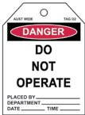
Caution | Yellow background with black border and black symbol
Emergency equipment | Green background with white symbol
Required protective equipment | Blue background with white symbol

There are also other types of safety documentation your employer will give to you that should be regarded as part of the rules for doing your job. These should include:
- work instructions or procedures,
- site plans,
- induction material,
- operational manuals for your truck or machine, and
- material safety data sheets.

It may be part of your job to make sure signs are erected prior to doing something. These may include:
- putting out hazard triangles if you break down on the edge of a road, or
- placing a ‘Do not operate’ tag to warn other operators about a damaged or defective piece of plant or equipment.

Emergency plans and procedures
During log haulage operations, sometimes things do not go as expected. All forest workers should know what to do when things do not go to plan so that you can stop things getting worse and you can get help.

The most likely emergency situations that you will come across in haulage operations are the following:
- motor vehicle incident,
- loss of log on public road,
- injured worker,
- unauthorised persons entering a workplace,
- small fire started by haulage operation, or
- spills of fuels and oils.

Section 17 provides examples of emergency plans for the above emergency situations.

Significant workplace health and safety issues
Issue resolution is the process you use to make sure that a serious threat to the health and safety of any person is dealt with immediately. You should not be placed at financial disadvantage because you raise a health and safety issue.

The following procedure has been designed to comply with relevant safety laws associated with issue resolution. Different workplaces may have different procedures for issue resolution. You should be told about these when you are inducted. If you are not happy with the outcome of an issue resolution process, you have the right to ask for help from other parties.

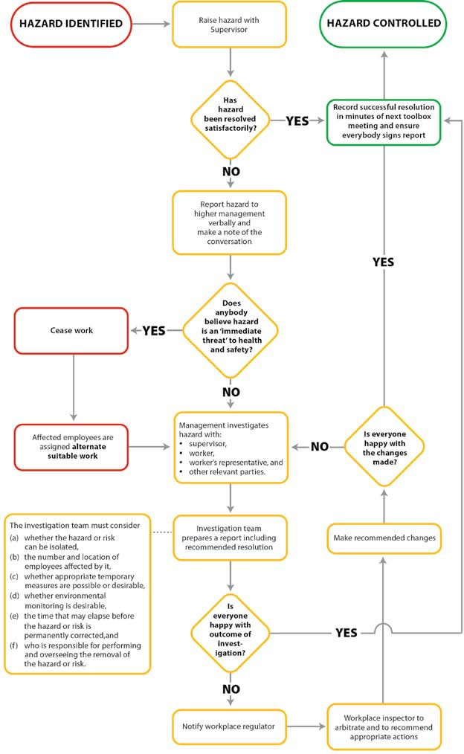

Incident and hazard reporting
If you or another person is injured or nearly injured while doing your work, it is important that you bring this information to the attention of your manager. You should tell your employer or contract manager either verbally or in writing so that:
- you receive the appropriate support and treatment for any injury,
- your employer or contract manager can notify regulators where necessary, and
- an investigation can be carried out to work out what went wrong and what can be done to stop a similar incident happening again.

If you are injured
If you are injured at work you should:
- immediately notify your employer in writing of your injury or illness,
- seek appropriate treatment so that you can return to full health as soon as possible,
- actively participate in any rehabilitation programmes and talk regularly with your employer and doctor about what you can do to recover and return to work,
- decide whether you want to lodge a claim,
- refer to the websites of the workplace authorities in your state or territory to find out more about your entitlements.

If you do not claim compensation:
- your time off work may be covered by sick leave or you can take leave without pay, and
- any treatment expenses will need to be paid for by you.

Road accidents
If you are injured in a transport accident your claim for compensation may be handled by the authority responsible for transport accidents in your state or territory.

Notifiable incidents

Your employer or contract manager is required to report notifiable incidents to relevant workplace regulators in each state. A failure to report such incidents may result in significant fines.

The definition of notifiable incidents varies across Australia but in general includes:
- workplace fatalities,
- serious injuries, and
- incidents that expose a person to an immediate risk to their health or safety.

In most states the loss of a log from the back of a truck onto a public road is a notifiable incident.

Learning from incidents
All incidents should be investigated so that they do not happen again. It is important to be thorough and strategic when investigating them. A good investigation process has the following steps:

Notification
All dangerous occurrences and actual incidents need to be written down on your incident report form.

Investigation

Who should be involved in the investigation of an incident will depend on the incident. Generally the person involved and their manager need to be included. Other people may include representatives of your customers, a workplace inspector or specialists.

Identification of root and contributing causes
  - It is important that an investigation identifies the main thing that contributed to the
dangerous occurrence or incident (the root cause).
  - It is also important to identify factors that contributed to the dangerous occurrence or incident but did not cause it (contributing causes).

Corrective and preventative actions

For the root cause and each contributing cause, develop a plan using the hierarchy of risk control (refer to page 9) to reduce the chance of a similar event.

Consultation
Once a plan has been developed to address the dangerous occurrence or incident, the plan should be discussed with all affected workers in a toolbox meeting.

Close out
After the changes have been implemented, it is useful to check that they have worked. The best way to do this is to review the incident at a toolbox meeting.

Legislation

5. Heavy Vehicle National Law
The Heavy Vehicle National Law is the primary source of regulatory requirements for road transport and is administered by the National Heavy Vehicle Regulator. It has application in all states and territories, except Western Australia and the Northern Territory.

Chain of responsibility
Chain of responsibility is a key aspect of the Heavy Vehicle National Law. The main purpose of chain of responsibility is to ensure that drivers are supported in making heavy vehicle operation safe. The fundamental areas included in the chain of responsibility law are:
  - mass compliance,
  - dimensional compliance,
  - driver fatigue management, and
  - load restraint compliance.

The table below shows a summary of the key roles and responsibilities for the people involved in the chain of responsibility regulatory requirements.

 | Consignor | Packer | Loader | Transport operator | Driver | Receiver
Mass compliance | ✓ |  | ✓ | ✓ | ✓ | ✓
Package mass identification |  | ✓
Dimensional compliance | ✓ |  | ✓ | ✓ | ✓ | ✓
Driver fatigue management | ✓ |  |  | ✓ | ✓ | ✓
Transport timeframes | ✓ |  |  | ✓ |  | ✓
Adhering to speed limits |  |  |  |  | ✓
Load restraint compliance | ✓ |  | ✓ | ✓ | ✓ | ✓

The various roles in the supply chain are:
  - the consignor, which may include forest owners or log purchasers who arrange the delivery of logs or other forest produce,
  - the packer, which may include a person assembling packs of fence posts,
  - the loader, which may include the person who places logs or other forest produce on the truck,
  - the transport operator, which may include haulage or harvesting contractors who own and operate trucks, the driver, and
  - the receiver, which may include a log yard manager at a processing or export facility.

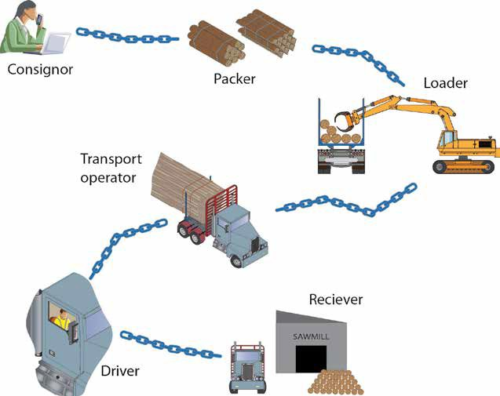

Mass limits
Mass limits are applied to heavy vehicles based on the axle configuration of the vehicle combination.

Maximum axle mass loadings

The table below shows a summary of the permissible axle loads for each key axle group type assuming single tyres with width less than 375 mm.

 | Single axle maximum load  (tonnes) | Dual axle maximum load (tonnes) | Tri-axle maximum load (tonnes)
Single tyre | 6  6.5*** | 10 (non load sharing)  11 (load sharing) | 15
Dual tyre | 8.5 (pig trailers) 9.0*** | 15 (pig trailers) 16.5*** | 20
*** Vehicles compliant to the following standards may have 6.5 t steer axle loads:
  - Engines compliant to ADR 80/01 (Euro IV).
  - Front Under-run Protection (FUPS) compliant to UN ECE Regulation no. 93 or ADR 84.
  - Cabin strength meets requirements of UN ECE Regulation no. 29.

Dimension limits
Heavy Vehicle National Law regulates maximum dimension limits for rear overhang, width and height.

Overhang limits for semi-trailers and dog trailers
Maximum rear overhang is the shorter of 60% of the ’S Dimension’ or 3.7 m.
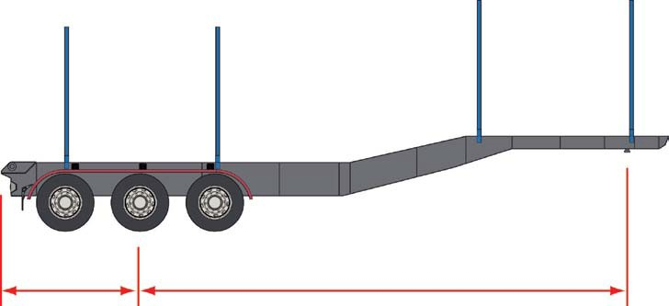
Rear Overhang
S Dimension

Maximum height Maximum width

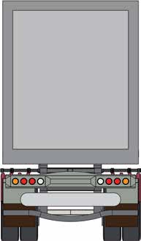
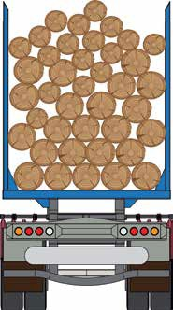
4.3 m
2.5 m

The maximum height limit is 4.3 m unless otherwise permitted.
The maximum width limit is 2.5 m unless otherwise permitted.

Typical vehicle combination maximum gross mass and length
The diagrams below show the permissible gross masses and maximum lengths for common vehicle combinations used in the transport of logs and other forest products. These standards are generally referred to as General Mass Limits (GML).

Local arrangements between transport operators and road management authorities may permit variations in mass limits, lengths, axle spacing and overhang specifications. You should confirm the load specifications with your employer.

B-Double Combination : Maximum Gross Mass : 62.5 tonne
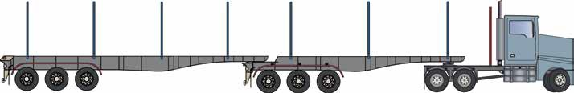

20 t GML
20 t GML 16.5 t GML 6 t GML
25 metres

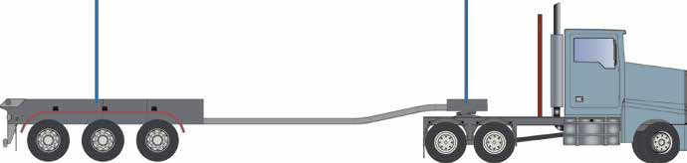
Jinker Trailer : Maximum Gross Mass : 42.5 tonne

20 t GML

19 metres

16.5 t GML 6 t GML

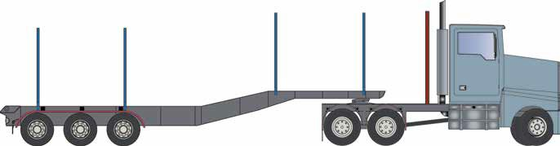
Semi-Trailer : Maximum Gross Mass : 42.5 tonne

20 t GML

16.5 t GML 6 t GML
19 metres

Quad Dog Combination : Maximum Gross Mass : 42.5 tonne
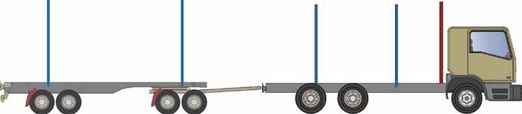

19 metres
20 t GML
16.5 t GML 6 t GML

Fatigue
Managing fatigue for all parties involved in the transport of logs and forest products is a key requirement of chain of responsibility regulatory requirements. All key duty holders should implement systems to reduce the likelihood of drivers operating heavy vehicles when affected by fatigue. There are three levels of fatigue management available for transport operators and drivers.

Standard Hours
Heavy Vehicle National Law regulates standard hours that drivers cannot exceed without prior special arrangements. The table below describes the maximum work time and minimum rest time for specified periods.

Specified period | Maximum work time | Minimum rest time
5½ hours | 5 ¼ hours | 15 minutes continuous rest time
8 hours | 7 ½ hours | 30 minutes rest time in blocks of minimum 15 minutes
11 hours | 10 hours | 60 minutes rest time in blocks of minimum 15 minutes
24 hours | 12 hours | 7 continuous hours stationary rest time
7 days | 72 hours | 24 continuous hours stationary rest time
14 days | 144 hours | 2 x night breaks and 2 x night rest breaks taken on consecutive days

Basic Fatigue Management
Basic Fatigue Management is a special arrangement that allows drivers and operators who obtain accreditation greater flexibility. The table below describes the maximum work time and minimum rest time for a specified period.

Specified period | Maximum work time | Minimum rest time
6¼ hours | 6 hours | 15 minutes continuous rest time
9 hours | 8 ½ hours | 30 minutes rest time in blocks of minimum 15 minutes
12 hours | 11 hours | 60 minutes rest time in blocks of minimum 15 minutes
24 hours | 14 hours | 7 continuous hours stationary rest time
7 days | 36 hours | Blocks of 7 continuous hours stationary rest time minimum
14 days | 144 hours | 24 continuous hours stationary rest time taken after no more than 84 hours work time and 24 continuous hours stationary rest time and 2 x night rest breaks and 2 x night rest breaks taken on consecutive days.

A further option is accreditation under Advanced Fatigue Management. It provides the greatest flexibility for transport operators for work and rest time. Refer to the National Heavy Vehicle Regulator for more information.

Load restraint
Heavy Vehicle National Law specifies a performance standard for load restraint. This is described on page 186 of the Load Restraint Guide.

The performance standard nominates forces in the lateral and vertical planes. The standard nominates forces as a proportion of ‘g’ that the restraint system must be able to withstand. ‘g’ is the symbol used to represent the force of gravity. The downward force of an object sitting on a plane is calculated by multiplying its mass by ‘g’. Therefore, the performance standard can be simplified by referring to its requirements as a percentage of the cargo mass. The diagram below indicates the percentage of the cargo mass that must be restrained by the load restraint system. A reference to 0.8 g means the same thing as 80% of the cargo mass.
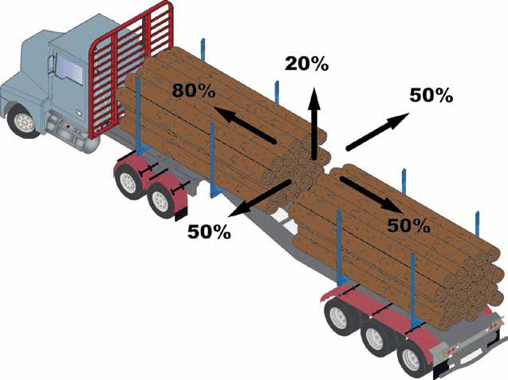

The forces nominated in the performance standard are much higher than normal forces experienced by the vehicle under normal operating conditions. The forward forces provided in the performance standard are usually only experienced when a heavy vehicle collides with a light vehicle.

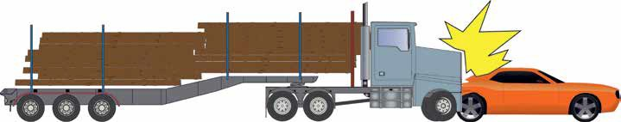

Forces developed in the vehicle
The forces that heavy vehicles develop when braking vary depending upon the speed of the vehicle. There are speed ranges that present greater risks for load restraint performance when the vehicle is braking. The following graph outlines typical forces for conventional braking systems.

Modern Electronic Braking Systems (EBS) improve braking efficiency and reduce stopping distances but increase stopping forces. Forces may exceed 0.8 g.

10 – 20 km/h
0.7 g
40 – 60 km/h
80 – 100 km/h
0.6 g

0.4 g
Force

Time

Vehicle Speed 10 km/h – 20 km/h
- Braking efficiency is high and the force on the logs is high, however the vehicle stops quickly so the force is not applied for a long period of time.
- Logs are unlikely to move into the vehicle cabin.
- This is a medium risk speed for load restraint failure.

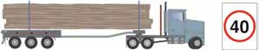
Vehicle Speed 40 km/h – 60 km/h

- Braking efficiency is medium and the force on the logs is high and the force will be applied on the logs for a reasonable time, as stopping distance is several vehicle lengths.
- The extended time that this force is applied to the logs is more likely to cause the logs to move into the vehicle cabin.
- This is a high risk speed for load restraint failure.

Vehicle Speed 80 km/h – 100 km/h
- Braking efficiency is low and the vehicle takes a long time to stop.
- The force applied to the logs is low and is less likely to cause the logs to move into the vehicle cabin.
- This is a medium risk speed for load restraint failure.

Load restraint systems
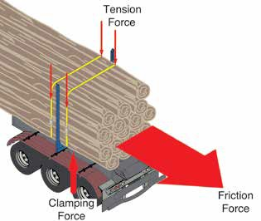
Load restraint systems typically fall into two key areas:
- tie-down systems, and
- direct systems.
Tie-down systems are based on the combination of downward clamping forces and friction between the surfaces. There is no physical connection between the logs and the trailer. The restraint is only from the frictional force generated from clamping forces and friction. These systems are explained in more detail on the following pages.

Direct restraint systems
Direct load restraint systems are methods that employ
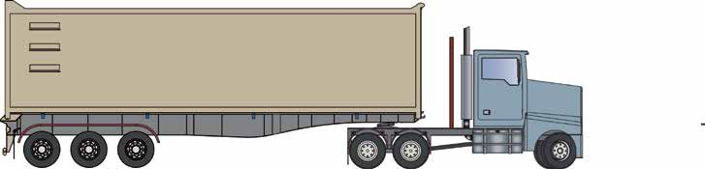
physical containment or a blocking structure. Alternatively, the use of lashings that provide a physical connection between the load and the trailer structure are also direct restraint systems.

Tipper tub provides direct restraint for wood chip products.
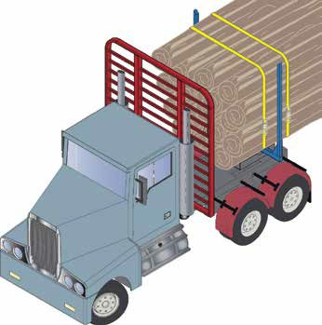
31 | Log Haulage Manual
The cab guard may not be designed to be a form of direct restraint.
Stanchions provide direct restraint for sideways applied forces.
Lashings provide restraint for forwards and rearwards forces.

Why friction is important
The friction of the logs will vary between species and is also dependent on the season. Lower friction logs will need more lashings to provide the necessary restraint.

Medium friction logs:
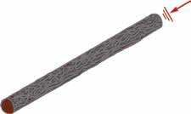
Logs with bark on and a low sap content.

0.5 – 0.6 g friction

Low friction logs:
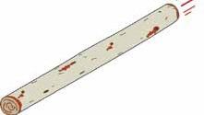
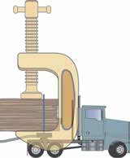
Debarked logs with high sap content.

0.2 – 0.3 g friction

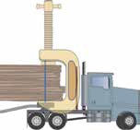
= less clamping needed

Fewer number of

lashings.
= more clamping needed

Higher number of

lashings.

The following diagram illustrates the impact of friction, it provides more initial resistance to movement and each lashing is more effective.
0.8 g
6
3

0.48 g

0.32 g
Clamping needed from chains to reach 0.8 g
forward restraint
1
2

Initial resistance to movement due to dynamic friction
Clamping needed from chains to reach 0.8 g
forward restraint
2
3
4
5

Initial resistance to movement due to dynamic friction
1

Medium friction Low friction

Tie-down systems
Tie-down restraint systems are made up of

tensioning devices,
- lashings, and
- anchor points.

The whole system must be rated to withstand the required forces.

Tensioners
Tensioners are used to pre-tension a lashing. The lashing pre-tension is the force developed in the
lashing from the tensioner. The following diagrams describe typical pre-tension capacities.

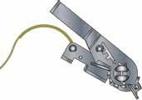
Low pre-tension tensioner – 300 kg capacity

Standard push up ratchet for 50 mm webbing strap

Medium pre-tension tensioners – 600 kg – 750 kg capacities

High pre-tension ratchet and continuous loop with chain hooks
Over-centre lever load binders (dogs) are hazardous items of equipment. The lever and associated extension bars (cheater bars) can release energy very quickly and cause injury to users. Drivers and transport operators should seek to use alternative tensioners.

Standard over- centre tensioner

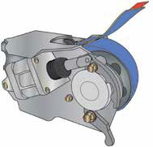
High pre-tension tensioners – 1000 kg or more

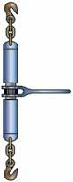
High pre-tension turnbuckle
To achieve correct tensions, it is important that air pressures used to energise auto- tensioners and the amount of webbing on the spindle when in operation should be set at levels recommended by the supplier.

Lashings
Chain or webbing may be used to tie down a load. The level of clamping provided by the lashing is key to the performance of the load restraint system. The clamping tension developed by the lashing is vastly different to the rated lashing capacity of the chain or webbing.

In general, the higher pre-tension of the lashing, the more effective the load restraint capacity of the lashing. Logs can slide a long way before the lashings reach their rated capacities, hence the restraint at the pre-tension is critical to the overall restraint performance.

The lashing capacity is the maximum force that can be applied to the lashing within its rated capacity.
Lashing Type | Typical lashing capacity/(tonnes)
50 mm webbing | 2 – 2.5
75 mm webbing | 2.5 – 5
6 mm transport chain | 2.3 – 3
8 mm transport chain | 3.8

Chain
Transport chains should comply with AS/NZS 4344:2001 Motor Vehicles – Cargo systems – Transport Chain and Components.

If grab hooks are used then the lashing restraint system is derated by 25%. Claws or winged grab hooks must be used to obtain full recognition of the rated lashing capacity. However, the
use of claw hooks is not recommended because a small settling of the load may result in the claw disengaging.

Chain is heavy to handle but it only stretches about 2% under tension.

Webbing
Webbing straps should comply with AS/NZS 4380:2001 Motor Vehicles – Cargo systems – Transport webbing and components.

Webbing straps should be inspected each use and any that are faded, stiff or abraded should be retired from use.

Webbing is easy to handle but it stretches more than 10% under tension, hence logs may move beyond stanchions.

4344 is the Australian Standard Number.
2.5 represents 2.5 t
lashing capacity.

A typical webbing tag with the required markings as per the Australian Standard 4380.

Any lashing type must be replaced if it is worn by more than 10%.

Load shift
Allowing some controlled movement in the log load will increase clamping and improve restraint with fewer lashings. The maximum movement of the load must not allow the logs to slide past the stanchions and become unstable.
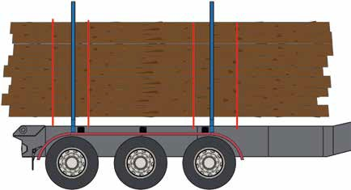
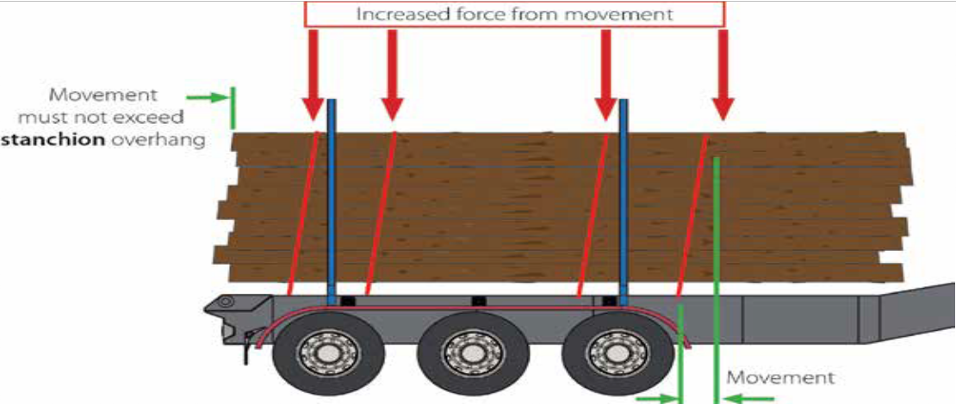
Force from tensioner pre-tension

All states and territories of Australia have laws regulating the impacts of humans on the natural environment and quality of life. Many states have laws that control what people working in the forest industry can and cannot do in order to control the impact of harvesting and haulage operations on the natural environment and local communities. These laws may take the form of:

6. Caring for the environment
- planning permits or consents to work in a particular area or undertake a particular activity,
- controls on outputs from operations like noise, oil pollution or the run off of dirty water from roads,
- rules about what types of trucks can use what roads and at what time of day, and
- Codes of Practice.

It is important that you ask your manager if there are any local rules that apply to a haulage operation before you start an operation.

Codes of practice
In some states, the laws controlling forestry operations are consolidated into a Code of Practice. It may be necessary for you to obtain specific training about the contents and how they relate to your work in order to get a licence to operate in a forest. In other states, Codes of Practice have been developed by the industry to self-regulate their activities.

Details about the Code of Practice and the agency responsible for enforcing it in your state is included in Section 14.

Certification
Certification is essentially concerned with demonstrating conformance to a set of documented requirements of an independent certification body. The requirements deal with the management of forests for the production of forest products (both wood and non-wood). Certification is a voluntary choice made by many forest growers driven in the main by the requirements of international markets.

Forest growers in Australia seeking to certify that their forests are well managed have a choice of the Forest Stewardship Council® (FSC®) or the Australian Forestry Standard (AFS). The schemes are similar but not identical.

FSC® certification

The Forest Stewardship Council® is an organisation with the stated purpose of improving forest management worldwide by establishing consensus on what good forest management means. The primary document used to verify if an organisation responsible for forest management is conducting good forest management is the FSC® Principles and Criteria.

These principles and criteria apply internationally to all types of forests irrespective of factors such as size, forest type, location or ownership arrangements.

AFS certification
The Australian Forestry Standard (AFS) is a standard accredited by the Standards Accreditation Board of Standards Australia. The AFS is administered by the Australian Forestry Standard Limited (AFSL), which is a not-for-profit public company.

The Australian Forestry Standard is recognised by the global Programme for the Endorsement of Forest Certification (PEFC) to enable the international trade of timber products from AFS certified forests. The PEFC is an international, non-profit, non-governmental organisation dedicated to promoting sustainable forest management.

Auditing
As a driver or loader you may be interviewed by an auditor conducting a certification audit. The forest manager responsible for the area you are working in should provide you with information to help you answer these questions.

Looking after roads and water quality
The most significant impact harvesting and haulage operations have on water quality is sediment run off from unsealed roads. For this reason, haulage operations should cease when persistent wet weather or damage to the road surface compromises road drainage and water quality.

Your truck may be fitted with a device on the wheels that regulates tyre inflation. These devices are designed to match the load to the road and the conditions you are driving in. If used correctly, they can reduce the impact on roads, reduce tyre wear and improve handling in difficult conditions.

If your truck is fitted with these devices, you should familiarise yourself with the controls to operate them.

Continuing to operate in deep mud can cause damage to truck transmissions and differentials. You should report such adverse conditions to your employer and forest manager. There are limits to operating in muddy conditions in many Codes of Practice.

Dust
In dry conditions, the integrity of road surfaces can be affected by load haulage operations. Haulage operations should cease when persistent dry weather causes the surface materials to disintegrate to a degree that poses a threat to water quality if there was a storm event, unless arrangements are made to repair the road.

Continuing to operate on disintegrated road surfaces can block radiators and cause damage to truck transmissions and differentials. You should report such adverse conditions to your employer and forest manager.

Noise
Many rural communities are sensitive to the noise from log haulage operations. In some towns, there are rules or agreements that limit the time of day trucks can operate. You should respect these limitations.

You can minimise the amount of noise from your truck by careful gear selection and braking technique.

Rubbish
Forests are natural environments. It is important that no litter or rubbish is left behind in the forest.

Waste oil, empty drums, discarded machinery parts and other waste must be removed from the forest and taken to an approved disposal facility.

Incident reporting
If there is a spill of fuel or oil from your truck or machine you should report this to your employer or forest manager. They may also need to report this spill to the relevant regulatory authority.

Daily maintenance and pre-start check recommendations

7. Maintenance and inspection
Vehicles involved in the transport of logs and other forest products often operate in very demanding conditions. To maximise the operational safety and reliability of these vehicles, a suitable maintenance and pre-start check regime should be in place.

The recommended pre-start checks for prime movers and trailers are provided in the tables below.

Daily maintenance and pre-start check recommendations : prime movers

Item | Prime mover check | Pre-start | In transit stop
Headlamps | Operating effectively | ✓
Brake lights | Operating effectively | ✓
Indicating lights | Operating effectively | ✓
Hazard lights | Operating effectively | ✓
Windscreen | Clean and free from obstruction to vision | ✓
Windows | Clean and free from obstruction to vision | ✓
Cooling fluid levels | Above minimum level | ✓
Hydraulic fluid levels | Above minimum level | ✓
Tyres | Tyre pressure | ✓ | ✓
 | Tyre tread depth above minimum for tyre | ✓
 | Tread wear pattern is acceptable | ✓
Wheels | Wheel nut indicators | ✓ | ✓
 | Wheel hub temperatures | ✓ | ✓
 | No obvious damage to wheel structure | ✓ | ✓
Suspension | Shock absorber free from leaks | ✓
 | Shock absorber becomes warm after travel |  | ✓
 | No air leaks | ✓
5th wheel / turntable | Engagement of king pin on turntable | ✓ | ✓
 | Visual inspection of 5th wheel connection to subframe | ✓
Cabin and body | Cabin and body free of damage and sharp edges | ✓
 | Bonnet catches secure | ✓ | ✓
 | Seat belt securely anchored and undamaged | ✓
 | Number plate intact and legible | ✓

Daily maintenance and pre-start check recommendations : trailing equipment

Item | Trailing equipment check | Pre-start | In transit stop
Service brakes | Operational | ✓
Handbrake | Operational | ✓
Mirrors | Intact, clean and secure | ✓ | ✓
Wipers | Clean and secure | ✓
Warning triangle | Clean, intact and supplied
Brake lights | Operating effectively | ✓
Indicating lights | Operating effectively | ✓
Hazard lights | Operating effectively | ✓
Tyres | Tyre pressure | ✓ | ✓
 | Tyre tread depth above minimum for tyre | ✓
 | Tread wear pattern is acceptable | ✓
 | Tyre size is correct | ✓
Wheels | Wheel nut indicators | ✓ | ✓
 | Wheel hub temperatures | ✓ | ✓
 | No obvious damage to wheel structure | ✓ | ✓
Suspension | Shock absorber free from leaks | ✓
 | Shock absorber becomes warm after travel |  | ✓
 | No air leaks | ✓
Braking system | Service brakes operating correctly | ✓
5th wheel / turntable | Engagement of king pin on turntable | ✓ | ✓
 | Tug test completed with prime mover | ✓
 | King pin in good condition | ✓
Equipment | Load restraint lashings within 10% wear | ✓
 | Load restraint lashing tension |  | ✓
 | Bolsters straight and free from damage | ✓
Mudguards and spray suppressants | Mudguards secure and complete | ✓
 | Spray suppressants secure and complete | ✓
Trailer structure | Number plate intact and legible | ✓
 | Ring feeder free from damage | ✓
 | Reflectors intact and functional | ✓
 | Registration label intact and legible | ✓
 | Rear marker labels in place | ✓

The mobile plant used to load and unload logs have multiple potential risks that need to be understood by drivers and operators.

8. Mobile plant

High Risk Activity | Reduced Risk Solution | Preferred Solution
Dropping logs (logs falling from grips) | - Maintain distance from mobile plant of full boom length plus half length of log being handled | - Check log handling equipment for specific log lifting task  - Eliminate use of bottom lift only without top clamping when lifting attachments  (such as forklift tines)
Toppling of mobile plant | - Reduce maximum mass lifted | - Do not operate at a site with side slope of more than 5 degrees
Working close to mobile plant | - Ensure drivers remain in safe zone during loading  - Wear high visibility clothing | - Move vehicle at slow speed away from mobile plant area to eliminate potential interactions with mobile plant  - Install visual barricades to  provide a safe area to work

Soft ground or slopes can allow logs to fall from mobile plant.

Logs can fall further than their length.

A low risk distance is a minimum of full boom extension plus half length of log being handled.

Full boom extension
and half log length
Full boom extension
and half log length

Mobile plant equipment – log grip attachments
The mobile plant used to handle logs must have grip attachments that ensure the logs are adequately secured.

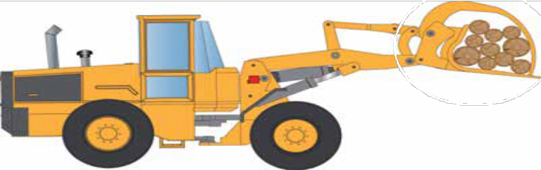
Log grip attachments must ensure the logs are secure.
✓

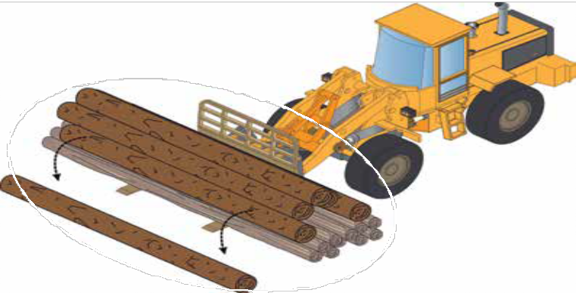
Forklift type attachments that have no clamping on the logs are not recommended and are high risk.
x
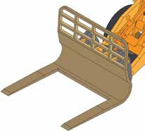
x

The mobile plant used to handle logs must have grip attachments that suit the task. All logs must be clamped by the grip attachments that clamp the logs effectively.

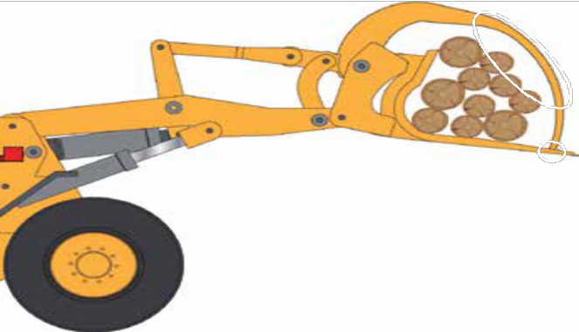
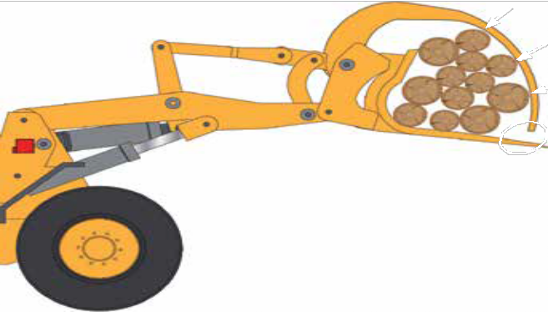
x
No force applied to logs.
Grip attachment at maximum closure.
✓
Force applied to logs.
Grip attachment not at maximum closure.

Logs not clamped by grip attachments.

Logs may fall out at any time during loading or unloading.
Logs are clamped by grip attachments. Log load stable for loading or unloading.

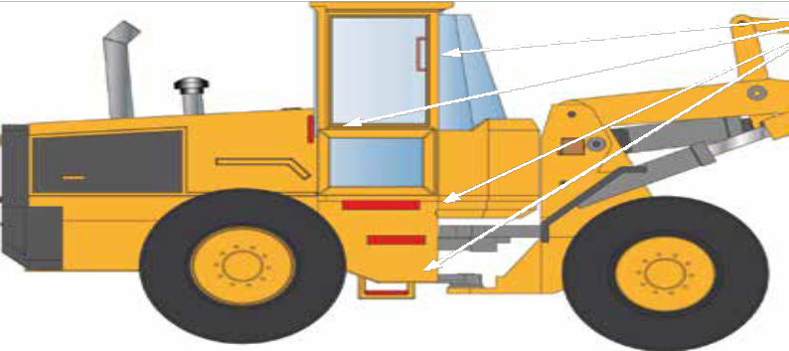
Mobile plant should be fitted with steps and hand grips to allow three points of contact to access or exit.
✓

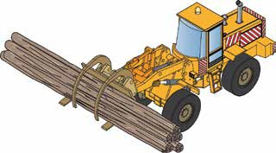
The visibility of mobile plant should be maximised.
- Reflective surfaces on all four sides of the plant.
- Adequate lighting for operator visibility.
- Consideration should be given to flashing lights for mobile plant when in transit.
- Flashing lights can be a distraction for operators when undertaking complex tasks.

Forwarders
Forwarders are specialised mobile plant and have particular risks relating to the stability of the logs on the load.
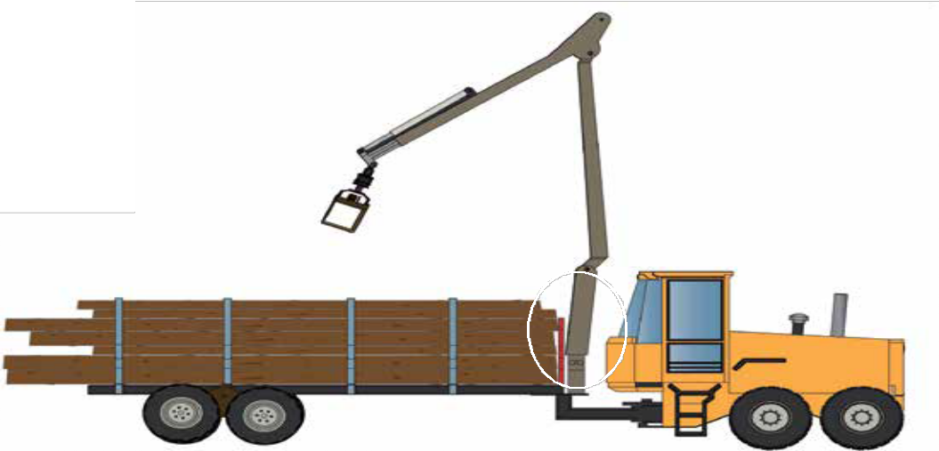
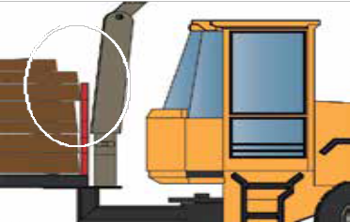
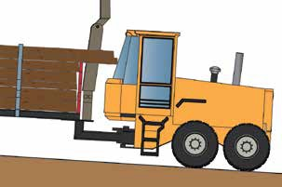
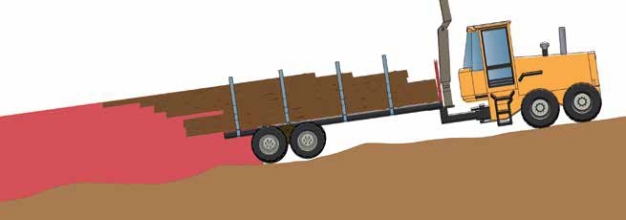
Logs loaded above the headboard on the forwarder are at high risk of sliding into operator cabins.
Travelling uphill can generate forces to slide logs into the operator cabin.

Travelling downhill can generate forces to slide logs away from the cabin and generate a high risk location downhill of the forwarder.

The driver and loader are both responsible for ensuring that the logs are placed on the truck trailer so they comply with all mass, dimension and load restraint laws.

9. Loading trucks

The loader is responsible for identifying a safe zone for the driver and ensuring that loading does not proceed unless the driver tells them that it is safe to start loading.

Prior to loading commencing the driver and loader should agree on the safe zone for drivers during the loading operation.

Life threatening hazards

TRUCK DRIVERS HAVE BEEN KILLED AND SERIOUSLY INJURED DURING LOADING OPERATIONS.

The main cause of truck driver fatality during loading operations is a failure of drivers to remain in their safe zone during the loading operation.

You must never enter the loader operator’s work zone while logs are handled.

High Risk Activity | Reduced Risk Solution | Preferred Solution
Fitting lashings during loading operation | No reduced risk solution | Do not begin fitting lashings  until all bays are loaded
Climbing on trailer to check load configuration | No reduced risk solution | Never climb on trailer during loading operation
Entering loader’s work zone to check load weight | - Ask loader to stop loading and load grounded, stable and the operator has given you permission to enter before entering work zone  - Do not begin loading until driver confirms they have returned to safe zone | Fit trailer with scales with  remote scale readout
Entering loader’s work zone to check load configuration |  | Ensure good visibility of trailer from safe zone
Branding / tagging logs during loading operation |  | Arrange with loader to get logs labelled prior to loading operation
Communicating with other  workers in noisy conditions | Driver and loader operator should agree on how to communicate with each other prior to commencing work | Driver and loader should communicate actively using a UHF radio while in a safe location

Safe zone
The driver and loader operator should agree in writing the location of the safe zone for the driver
prior to loading commencing.

The safe zone should have risk controls that address the following:
- logs falling on driver from mobile plant,
- logs falling on driver from trailer,
- verbal communication between driver and loader operator, and
- visibility of driver to loader operator.

The safe zone may include the cabin of the truck if the above risk controls are addressed and state and worksite standards allow it. However the cabin is not an acceptable safe zone if logs are lifted over the truck cabin.

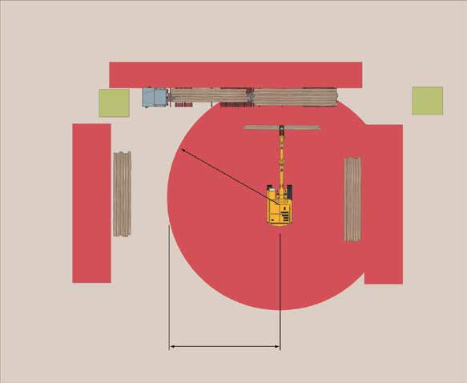
Safe zone recommended for locations out of vehicles
10 m
4 m
High risk zone = full boom extension
+ half log length

Safe zone

High risk zone

Log stack

The high risk zone for the loader is an area described by the boom length plus a half log length of the mobile plant. Safe zones must be established outside the high risk zone. Visual barricades may be installed to identify the loader’s work area.

High risk zones are:

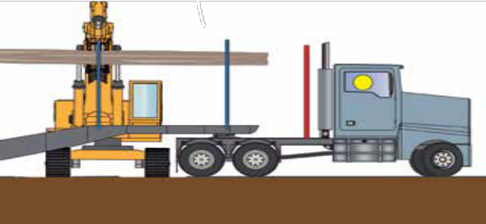
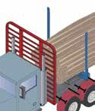
- opposite side of the vehicle from the mobile plant,
- opposite side of log stacks from the mobile plant, or
- anywhere closer to the mobile plant that is less than 15 metres.

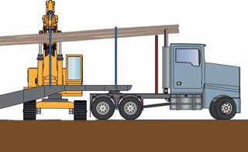
✓
X

Cabin is not an acceptable safe zone if logs are lifted over cabin of vehicle.
Where the safe zone is in the cabin of the vehicle a cab-guard, higher than the cabin, should be in place.

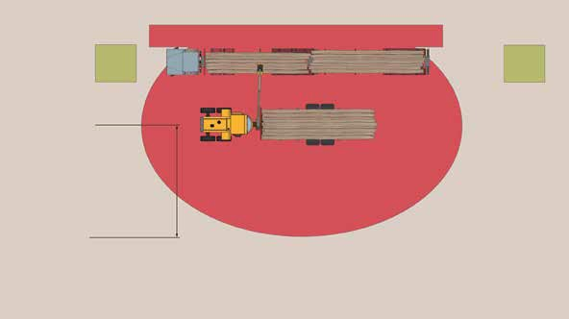
Safe zone
4 m
10 m
High risk zone =
full boom extension
+ half log length

High risk zone

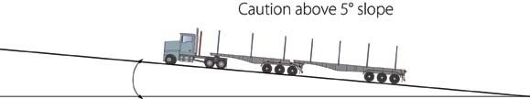

Risks of loading logs
In addition to the life threatening hazards identified in previous sections, loading of logs presents several risks that drivers and operators need to understand and implement risk solutions.

High Risk Activity | Reduced Risk Solution | Preferred Solution
Toppling of mobile plant  either sideways or forwards | - Clear people from potential fall zones  - Reduce the maximum lift weight by operator to allow for  effective slope | - Confirm area slope is less than 5 degrees  - Grade landing area to reduce slope if it is greater than 5  degrees
Rolling of truck during loading | - Confirm verbally (from the driver) that park brake is engaged prior to commencing loading by the loader  - Ensure engine is not running during loading  - Ensure keys are out of  ignition during loading | - Confirm road slope is less than 5 degrees  - Ensure truck runaway solutions are in place  - Ensure truck keys are placed in a location remote from  the ignition
Slipping, tripping or falling from truck cabin | - Minimise frequency of entering and leaving the truck cabin  - Use 3 points of contact when  climbing up or down from the cabin | - Install antislip surfaces on steps  - Ensure good lighting of steps and hand grips is provided
Slipping, tripping or falling while walking around landing | - Wear ankle high lace-up protective footwear while on landing | - Ensure driver remains in cabin during loading operation  - Provide driver with a designated lashing zone clear of loading operation in which slip, trip and fall hazards have been identified and controlled

Mobile plant operating on soft ground
Soft ground conditions can destabilise mobile plant during the loading of logs. This can result in the logs sliding out of the grips or the mobile plant toppling sideways.
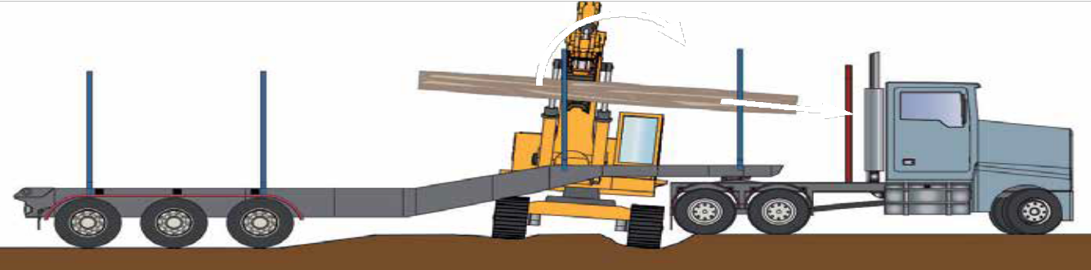

Landing conditions
The landing area presents risks due to the nature of the geography and the lack of permanent infrastructure for loading vehicles.

High Risk Activity | Reduced Risk Solution | Preferred Solution
Loading in poor light conditions | - Wear night rated high visibility clothing  - Use lighting on mobile plant | - Use artificial lighting that complies with requirements on page 12
Loading in poor weather conditions | - Use truck cabin as safe zone | - Provide driver with weather- proof safe zone on landing
Loading on inappropriate ground slope | - Position mobile plant to load uphill  - Ensure that all people are positioned outside of the potential log and boom arm fall zone | - Locate landing site at locations with cross slope less than 5 degrees  - Grade area for mobile plant  to less than 5 degrees
Loading on unstable ground | - Reduce maximum lifted mass to allow for reduced mobile plant capacity | - Compact landing area to provide stable base for mobile plant
Loading near hazardous trees | - Identify hazardous trees and exclude workers from within two lengths of a hazardous tree or two crown widths when broken limbs are hung up | - Remove all hazardous trees from within two tree-lengths of loading and lashing area

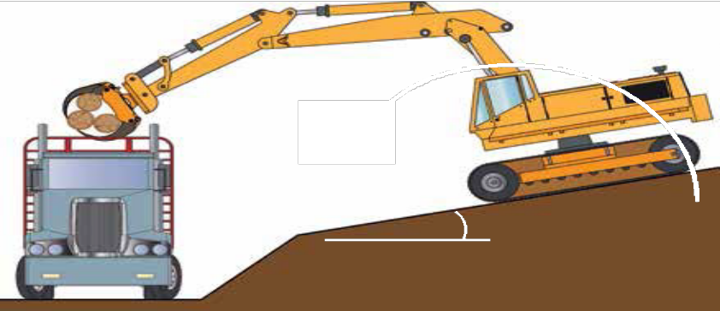
Maximum lift when operating on a slope, more than five degrees must be reduced from maximum capacity.

Caution above 5 degrees slope

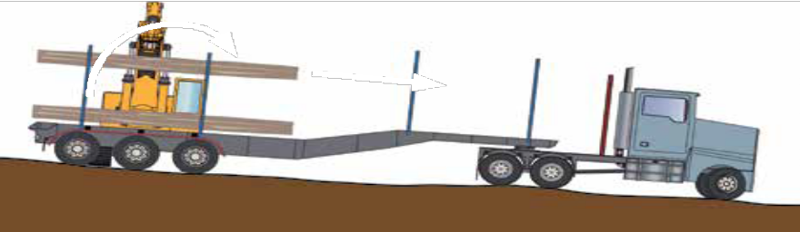
Operating on side slopes can cause logs to slide out of grips from mobile plant loading trucks.

Side slopes can also destabilise the mobile plant during loading.

Placing the load on the truck
The load must be placed on the vehicle to ensure:
- the load can be restrained effectively,
- the load does not destabilise the vehicle,
- the load remains stable when applying and removing lashings, and
- the load is not contaminated with items that can fall from the vehicle in transit.

The objectives when building a load are to:
- maximise the friction between the outer logs and the trailer, and
- ensure that contact between internal logs is maximised.

In order to achieve this, the loader operator should:
- begin building the first layer of logs from the furthest side,
- if possible, place larger logs at the base of the load,
- alternate logs with large tapers so that the top of the load is flat,
- ensure short logs do not create a point of weakness in the load, especially when pencilling, and
- use your boom to compact the load progressively.

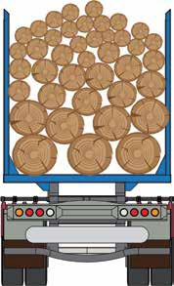
Putting a heavy log 20 cm lower in the base of the load will have the same effect on truck stability as placing it 60 cm lower at the top.

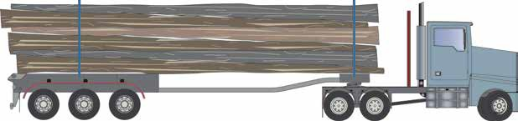
Alternate loading of logs with significant tapers.

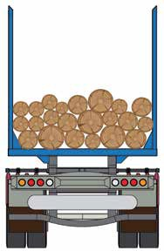
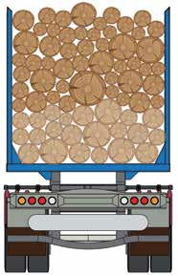
The base of the load affects the whole load. It is good practice to stop two or three times during the load build to consolidate the previous layer of logs.
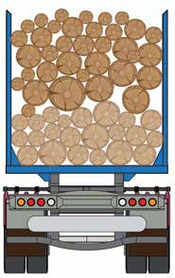
Avoid gaps in the load
Ensure that all logs contact the adjacent log

Load shape
The top of the load is critical for load restraint. The logs on top of the load must be crowned so that
lashings touch all of the outside logs. If possible, use smaller diameter logs at the top of the load.

As both the loader and the driver are responsible for the safety of the load, they should work cooperatively. It is difficult for the loader to see all parts of the load, so a driver can help by telling the loader what he can see while standing in the safe zone.
Logs not clamped

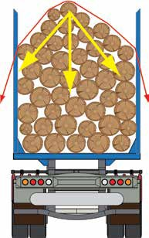
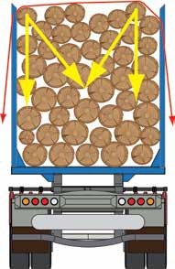
X ✓

Log loads that are flat across the top do not allow the lashings to clamp the logs effectively.

Height of logs
Crowning the logs allows the lashings to transfer clamping force through the load effectively.

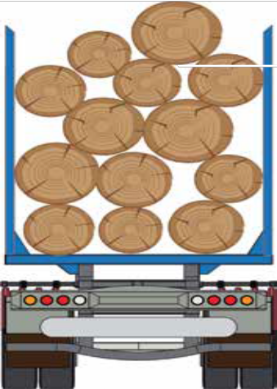
Stanchions will protect a driver from logs falling off the truck if logs are not stacked too high.
D
D/2
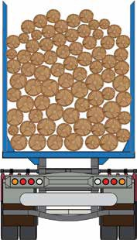
✓
Loading larger logs
above stanchion may be necessary but they should never be loaded more than half their diameter above the top of the stanchion.

Logs should be loaded below the height of the stanchion.

Sideways restraint
Minimum overhang of load must ensure logs are contained by stanchions when movement occurs.
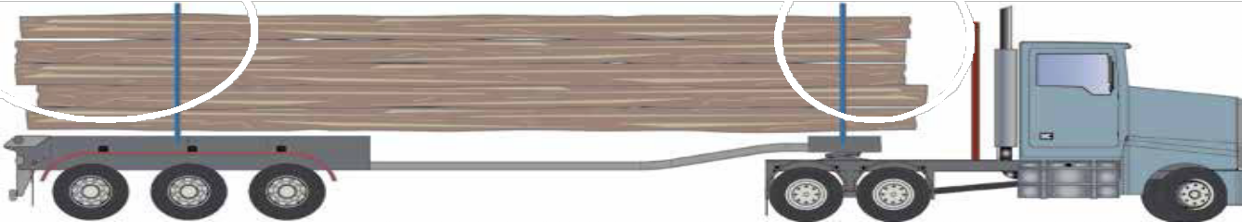

All logs must be contained by at least one stanchion to ensure that they cannot move sideways. Short logs should be held in the load by long logs. Logs not enclosed by a stanchion at each end must have a belly chain applied to attach these logs to the remainder of the load.
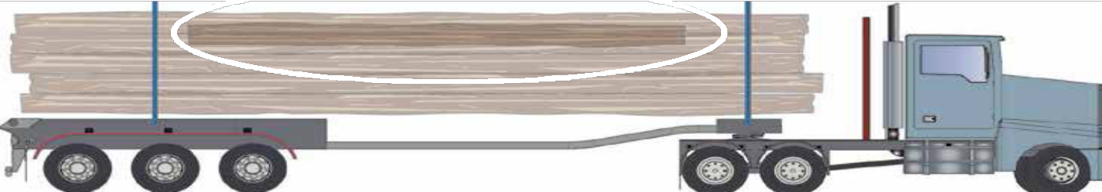
X
Logs not contained by stanchions should be minimised and must have a minimum of one belly chain applied to the portion of the log not contained by a stanchion. Logs cannot be restrained by belly chains alone. There must be a lashing that provides some clamping to the trailer.

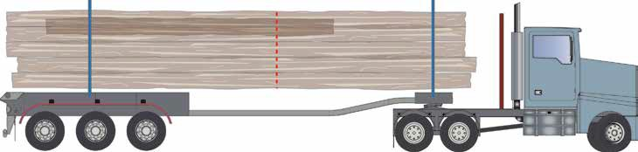

Small diameter logs on top of the load may break when the full force of tensioners are applied. Drivers should ask for machine assistance when unloading loads with small diameter, brittle logs as described on page 66.

Rocks and debris
The load of logs must be free from rocks and other debris that can become loose and fall from the vehicle in transit.

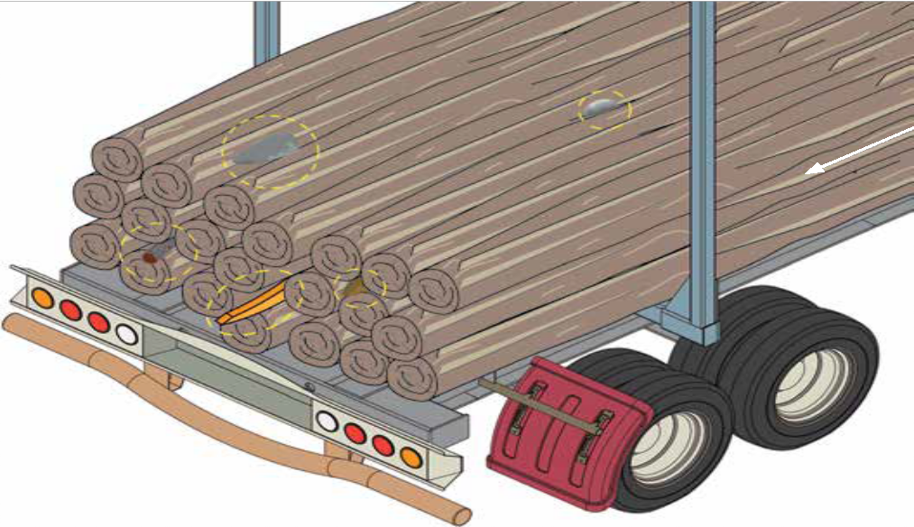
Branches should be trimmed before leaving the landing.

Logs should be stored on the landing so that contaminants do not end up in the load.

Strategies to reduce the risk of rocks contaminating loads include:
- check for rocks on loading area during site risk assessment,
- stacking logs on bearers,
- pencilling each grab of logs, and
- reporting any rocks found in loads to harvesting crew.

Drivers should check trailers and other flat surfaces for rocks and debris that may have fallen from the load prior to leaving the site and entering a public road.

Securing the load
Once the loader has completed placing logs onto truck, the driver must apply sufficient lashings to the load to satisfy the load restraint performance standard. The driver should walk around the load to check the load is compliant with mass, dimension and crowning requirements.

The driver should conduct a risk evaluation of the load to determine the number and types of lashings that need to be applied. A risk assessment should be available for each configuration of logs that is hauled. The risk assessment should consider:
- log friction,
- log overhang past stanchion,
- load height,

lashing capacity,
- lashing pre-tension, and
- the availability of load blocking devices.
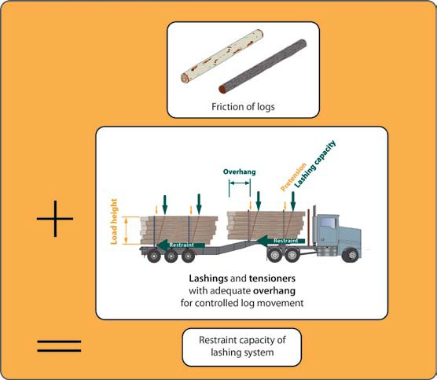
The outcome of the risk assessment should specify:
- the number and type of lashings required,
- the lashing pre-tension required, and
- any requirement to apply additional belly chains to assist with unitising the load.
Consignors and receivers should ensure that trucks have the capacity to adequately restrain specific log types when planning haulage operations and transport operators should ensure drivers are provided with the appropriate equipment.

Risk evaluation of log load and restraint
The diagram below shows the key issues that impact on the relative risk of the log loads.

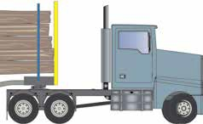

Log friction
Debarked logs with high sap content | risk reduces | Logs with bark and low sap content
Short overhang | risk reduces | Long overhang
Maximum load height | risk reduces | Lower load height
 | risk reduces
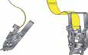
Standard | Standard 750 kgf | Air driven
300 kgf 50 mm | Chain tensioner | tensioner
webbing ratchet |  | 1000 kgf
risk reduces

Not blocked against headboard Blocked against headboard

Log overhang
past stanchion

Load height

Lashing pre-tension

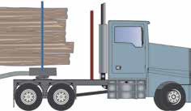
Forward blocking of load
risk reduces
High Risk Low Risk

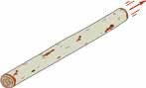
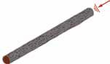

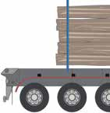
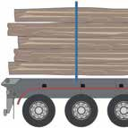

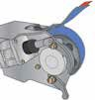

Restraining long logs
Long logs may be restrained using the number of lashings specified in the Recommended Restraints
table below if they meet the following criteria:
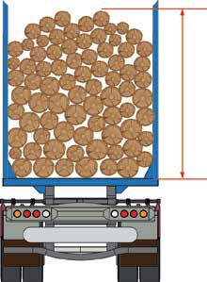
- logs with a static friction of approx 0.6 ‘g’,
- lashing pre-tension applied to both sides of bunk,
- winged grab hooks or claw hooks must be used with chains,
- clearance between cabin and logs (B) greater than rear stanchion overhang (A), and
- log overhangs as per the following table.
Bunk height (metres) | Chain | Webbing
1.5 | 0.4 | 0.6
1.5 – 2 | 0.5 | 0.7
2 – 2.5 | 0.6 | 0.9
2.5 – 3.0 | 0.7 | 1.1

Bunk height

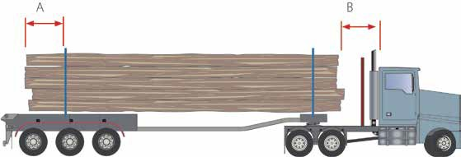
Minimum log overhang
Dimension B must be larger than dimension A

Minimum log overhang (metres)

Recommended Restraints (Refer to page 2 for an explanation of the legal status of these recommendations)

Bunk mass (tonnes) | 6 mm chain  LC: 2.3 tonnes  Pre-tension: 750 kgf |  | 6 mm ICE chain LC: 3 tonnes  Pre-tension: 750 kgf |  | 8 mm chain  LC: 3.8 tonnes  Pre-tension: 750 kgf |  | 75 mm webbing  LC: 5 tonnes  Pre-tension: 300 kgf
Cab guard location | Trailer | Prime mover | Trailer | Prime mover | Trailer | Prime mover | Trailer | Prime mover
15 – 20 | 3 | 3 | 2 | 3 | 2 | 2 | 3 | 3
20 – 25 | 4 | 4 | 3 | 3 | 2 | 3 | 4 | 4
25 – 30 | 4 | 5 | 3 | 4 | 3 | 3 | 5 | 5

Restraining short logs
Short logs may be restrained using the number of lashings specified in the Recommended Restraints
table below if they meet the following criteria:
- logs with a static friction of approx 0.6 ‘g’,
- lashing pre-tension applied to both sides of bunk,
- winged grab hooks or claw hooks must be used with chains
- minimum overhang of 0.5 metres,
- minimum clearance between cabin and logs of 0.5 metres, and
- bunk mass 15 tonnes or less.

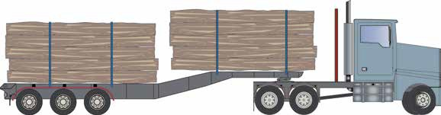
Minimum overhang 0.5 m
Minimum overhang 0.5 m
Minimum gap 0.5 m

Bunk height

Recommended Restraints (Refer to page 2 for an explanation of the legal status of these recommendations)

Bunk height (metres) | 6 mm chain  LC: 2.3 tonnes  Pre-tension: 750 kgf |  | 6 mm ICE chain LC: 3 tonnes  Pre-tension: 750 kgf |  | 8 mm chain  LC: 3.8 tonnes  Pre-tension: 750 kgf |  | 75 mm webbing  LC: 5 tonnes  Pre-tension: 300 kgf
Cab guard location | Trailer | Prime mover | Trailer | Prime mover | Trailer | Prime mover | Trailer | Prime mover
1.5 | 2 | 3 | 2 | 2 | 2 | 2 | 3 | 3
1.5 – 2.0 | 2 | 3 | 2 | 2 | 2 | 2 | 3 | 5
2.0 – 2.5 | 2 | 3 | 2 | 2 | 2 | 2 | 4 | 6

Key features of applying lashings for low risk loads
- All logs must be contained sideways by at least one stanchion and a lashing.
- Lashings must be applied to ensure the forwards and rearwards restraint is compliant.
- More lashings will be required when log friction is reduced.
- Lashing angles less than 90 degrees vertical will require more lashings or higher pre-tension.

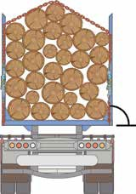
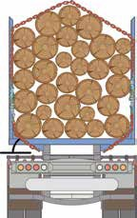
Lashing angle approx. 90 degrees. Fewer lashings needed.
Belly chains are not recognised as a tiedown lashing.
Belly chains are for combining logs and preventing single logs spearing from the load.

Lashing angle less than 90 degrees. More lashings needed.

Restraining high risk loads
Log loads with low friction, short overhangs, low tensions and non-compliant lashings
do not meet the criteria on previous pages and are high risk loads. High risk loads should be blocked in all directions.
They should be blocked using a combination of stanchions, headboards and tailboards. An option for the use of headboards and tailboards is given below.

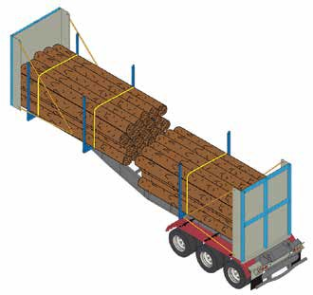
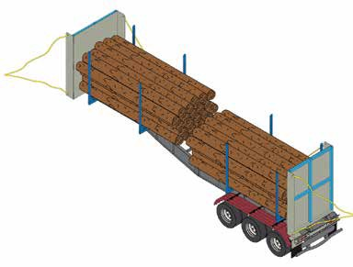

Headboards and tailboards can be movable or have removable sides to allow flexibility of loads and easier loading.

Headboards should be rated to a minimum of 50% of the load mass as a uniformally distributed force across the height and width of the headboard. This allows for transport of logs with reduced static friction values of 0.3.

Tailboards should be rated to a minimum of 20% of the load mass as a uniformally distributed force across the height and width of the tailboard. This allows for transport of logs with reduced static friction values to 0.3.

Load restraints will be required to restrain the load vertically.

The hazards that need to be controlled while applying lashings
Securing logs on trailers once loading has been completed presents risks to drivers.

High Risk Activity | Reduced Risk Solution | Preferred Solution
Toppling of log off load | - Ensure the maximum height of logs above stanchion is ½ of the diameter of the log | - Ensure logs are not loaded above height of the stanchion
Throwing lashing over load | - Use light rope to drag lashing  over loads  - Use loading machine grapple to assist in applying lashings | - Maximise the use of direct restraint solutions, such as headboards and tailboards, to reduce the number of lashings required
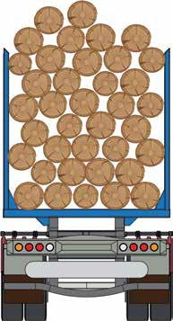
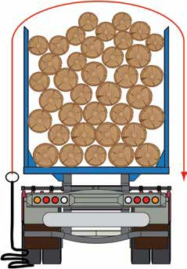

Logs can topple off loaded vehicles when loaded above stanchion height.
A light line can be thrown over log loads and used to pull heavier lashings over the load.

Loading other forest produce
Drivers of trucks carting chips from infield chipping operations should:
- use radio to get permission to enter loading area, and
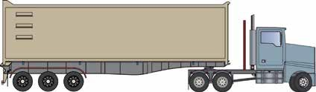
- remain in the cabin of the truck while the trailer is loaded.

If a driver needs to leave the cabin of the truck, they must not enter the exclusion area around the mobile chipper.

Using communication device wh
ile driving.

Life threatening hazards

10. Transporting logs

TRUCKS HAVE BEEN INVOLVED IN INCIDENTS THAT HAVE RESULTED IN THE DEATH AND SERIOUS INJURIES OF DRIVERS AND OTHER ROAD USERS WHILE TRANSPORTING LOGS AND OTHER FOREST PRODUCE.
The main factors involved with these deaths are:
- vehicle collisions,
- truck roll overs, and
- logs and other material falling off trucks.

To address these issues drivers must:
- ensure speed is appropriate for road condition and load configuration,
- check lashing tension is maintained throughout the journey,
- ensure there are no unrestrained logs or other debris that can fall out of the back or side of the load, and
- take designated rest breaks.
•
•
•
•

High Risk Activity | Reduced Risk Solution | Preferred Solution
Checking lashing tension on edge of highway | - Stop in designated rest area to check lashings | - Fit truck with auto-  tensioners
Driving on unfamiliar roads | - Ensure consignor provides detailed information about cartage routes | - Ensure transport operators induct drivers on all new routes
Driving on roads with potholes and other hazards | - Report hazards to employer / forest manager | - Cease cartage until hazards are controlled
Being distracted by loose items in cabin | - Conduct daily pre-operational checks for loose items | - Design storage space for loose items in cabin
Using communication device while driving | - Pull over prior to talking on phone | - Use hands-free mobile phones and radios

Load stability and truck rollover
The stability of log and other forest products in transit is a key issue for drivers and operators. The key factors that impact stability is the load centre of mass and vehicle speed.

Logs and other forest products that are loaded to maximum height are at high risk of vehicle rollover.

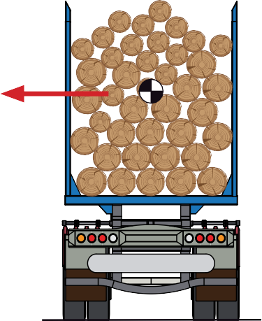
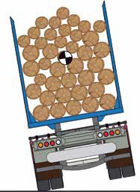
Static Rollover Threshold (SRT) is used to evaluate vehicle rollover risk. SRT is a measure of the sideways acceleration of the vehicle required to cause a rollover. The higher the sideways force (SRT) required to roll the vehicle, the better the stability of the vehicle. To reduce the risk of rollover to medium or low, the SRT should be 0.35 g or more.

Sideways force

Reducing risk of rollover
Static Rollover Threshold (SRT) should be 0.35 g or less to reduce the risk of rollover.

To reduce rollover risk, the following vehicle specifications should be considered:
- suspension, and
- electronic roll stability.

Suspension
Airbag suspension typically provides an improved resistance to rollover due to the limitation of maximum travel of the suspension.
Steel leaf suspension systems provide better initial resistance to rollover, however suspension travel can increase markedly once maximum loads are exceeded, resulting in significant sideways tilt of the vehicle.
Airbag suspensions maximise overall suspension stability.

Electronic roll stability
Electronic roll stability provides a system that samples the vehicle stability at the commencement of the journey and applies braking to individual axles to reduce vehicle speed during cornering. Rollover risk is minimised by reducing vehicle speed as the combination approaches rollover instability.

Impact of speed on rollover risk
The speed of the vehicle has a direct impact on rollover risk.
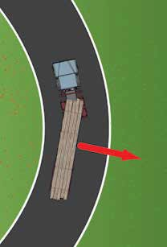
444%
444%
78%
178%
300%

300%
Increase in sideways force

178%

78%

30 40 50

60 70

Sideways cornering forces on vehicles:
For loads above the recommended heights nominated below, reduce vehicle speed prior to cornering by a minimum of 10 km/h.
- increase as vehicle speed increases, and
- increases as corner radius gets smaller (tighter).

Impact of centre of mass on rollover risk
Speed (kilometres per hour)

The centre of mass is related to the height of the bolster and the maximum load height. The following SRT of 0.35 ‘g’ for an airbag and steel suspension.

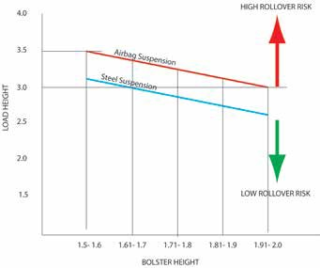
Bolster height
Centre of mass

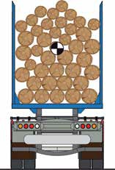
Maximum load height

Semi-Trailer Combination

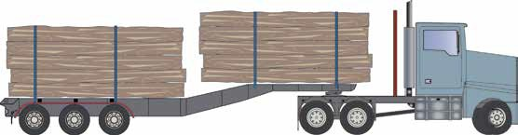
Maximum load height

Working with other trucks on forest roads
Trucks should all be fitted with 2-way radios so that they can communicate with other vehicles that are using narrow forestry roads. It is good practice to make a radio call every time you pass a significant landmark on the road to warn other vehicles that you are coming.

The protocol for loaded log trucks travelling away from the landing is to call: ‘Your name, loaded, your location’
Trucks travelling unloaded back to the landing call:

‘Your name, empty, your location’

If there are route markers available follow local communication protocols. For example some forest managers set up kilometre markers along major haul routes.

You should be provided with information about the appropriate radio channel to use when travelling in a forest area by the forest manager.

When driving on forest roads do not rely on other drivers to make check calls.

Life threatening hazards

11. Unloading trucks
TRUCK DRIVERS HAVE BEEN KILLED DURING AND SERIOUSLY INJURED DURING UNLOADING OPERATIONS.

High Risk Activity | Reduced Risk Solution | Preferred Solution
Toppling of log off load as  lashings are removed | - Use machine assisted unstrapping procedure | - Do not load logs above height of stanchion
Being struck by straps, chains or shackles while removing lashings | - Wear helmet and eye protection while removing lashings | - Look up at top of load while  lashings are being removed  - Use machine assisted unstrapping procedure if lashing gets snagged
Removing lashings close to other trucks or mobile plant | - Ensure unstrapping area is separated from traffic | - Place bollards around areas where people walk or work when outside of the truck or machine cabin
Slipping, tripping or falling while walking around log yard | - Remove loose bark and debris from unstrapping area frequently  - Wear ankle high lace-up protective footwear | - Construct sealed walkways and work areas for drivers and pedestrians
Unloading in poor light conditions | - Wear night rated high visibility clothing  - Use artificial lighting that complies with requirements on page 12 | - Install permanent lighting to illuminate unstrapping and unloading zones

Arriving at a site
Once you arrive at an unloading facility, you are required to follow the rules of the site. You may need to complete an induction prior to entering the facility. Each site will be different but you should familiarise yourself with the following:
- the process for weighing or estimating your load,
- what paperwork you need to give and receive so that you get paid,
- where to park so that you can remove your lashings safely,
- where to stand when your truck is unloaded,
- who to ask for help,
- first aid and incident management plans, and
- the location of facilities for meals and rest breaks.

Safe work areas
In order to safely unload a truck carrying logs a driver needs:
- a safe area to unstrap the load, and
- a safe area to stand while logs are lifted off the trailer.

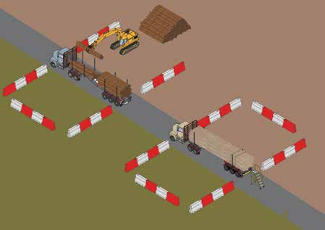
Options for marking exclusion zones
Safe zone
Unstrapping zone
Unloading zone

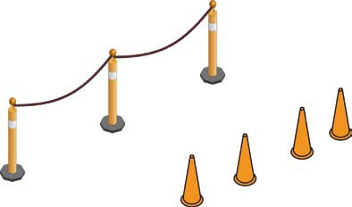

Unstrapping the load
Wait until the unstrapping zone is free.
Proceed to unstrapping zone, fit personal protective equipment and remove lashings.

Inspect load for hazards. These may include logs that have moved or broken since you secured your lashings. If you are at all concerned that the load is unsafe ask the loader for assistance.
Use the following unbuckling procedure.
- Release tension from lashing(s).
- Unhook shackle(s).
- Pull lashing to check it is free to move.
- If it is free to move, begin pulling lashing off load while walking backwards slowly.
- Once you are five paces from truck slowly pull remainder of lashing off load.
- Watch top of load to check for any log movement and the location of the shackle.
- If lashing becomes snagged stop pulling lashing and contact loader on UHF and follow
machine assisted unstrapping procedure.

Machine assisted unstrapping procedure
To be used if load has become unsafe in transit or lashing is jammed.
Site or local state rules may require the use of machine assisted unstrapping all the time.
- Notify loader operator using radio.
- Proceed to unloading zone.
- Move to safe zone and notify loader using radio.
- Loader to secure load and notify driver using radio once load is secured.
- Remove lashings. Jammed lashings may need to be cut.
- Do not climb on truck.
- ‘Loader must not move any part of their machine while driver is removing lashings.
- After lashings are removed, move back to safe zone and notify loader using radio.

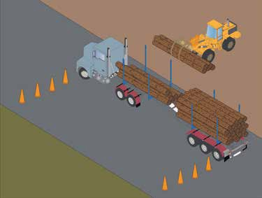
Never leave safe area without permission from loader.

Unloading and stacking out
- Proceed slowly to unloading zone with load unstrapped.
- Never drive past a pedestrian or other driver unstrapping their load while your load is unstrapped.
- Ask loader for permission to enter unloading area.
- Secure truck, fit personal protective equipment and move into safe zone.
- Notify loader operator when you reach safe zone.
- Leave safe zone when loader operator notifies you that it is safe.
- If necessary, proceed to a safe area to fold and secure trailers.
- Exit site.
Loader operators should not commence unloading until driver notifies them they are in the safe zone.

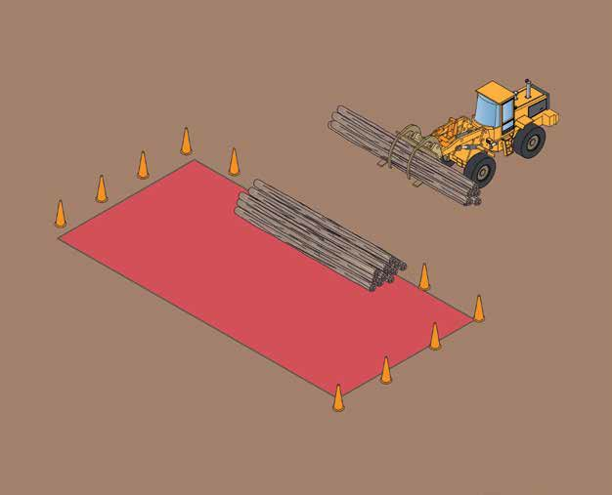

Warning log stacks can be unstable. Pedestrians should be excluded from the area around log stacks.

As a professional driver careful record keeping and paper work is part of the job.

12. Record keeping and paperwork

If you drive 100 km or more from your home base or operate under Basic Fatigue Management or
Advanced Fatigue Management, you must complete a work diary to record work and rest times.

If you do not drive more than 100 km from your home base, you should keep track of the hours you drive so that you can demonstrate you are not exceeding the regulated hours of work.

You should keep the following:
- records of daily pre-operational maintenance checks,
- details of the load you are carrying so that you can get paid, and
- records to verify that your on-board scales are accurate.

You may also need to fill in forms for the following reasons:
- reporting a hazard,
- reporting an injury, or
- suggesting an idea about how your job can be made safer or easier.

Haulage operations are an essential but significant part of the cost of growing and selling wood for the timber industry. In order to ensure the industry is sustainable, it is important that everyone takes care to minimise the costs associated with delivering logs.

13. Running a business

Orders and schedules
Before you begin your first load each day, many people have been involved in planning the operation. Your employer has negotiated rates with their customer. Important parts in the development of these rates are:
- an estimate of the number of trips to and from the forest you can do each day. If your job has been priced on the basis of doing four trips each day and you are only able to consistently complete three trips then it is likely that your employer will be losing money, and
- estimates of the amount of wood you can carry safely and legally. If the wood you is carrying is low friction, or the logs are short, you may not be able to restrain them with lashings only. Head boards and tail boards may have to be fitted to the trailer of your truck. This can reduce your pay load by more than one tonne.

The Heavy Vehicle National Laws recognise that you are only one part of the chain of responsibility. All parties in the chain, including you, are liable for big fines if the laws are broken. It is important that you understand these laws and highlight concerns to your employer if you believe the orders and schedules you are being asked to do are unsafe or illegal.

On the other hand, it is important that you work carefully and consistently to ensure that schedules are met wherever possible and running costs are minimised. Things you can do to help include:
- planning your day so that waiting times are minimised,
- be careful with your daily maintenance inspections so that problems are detected early, and
- drive so that fuel use, tyre and brake wear is as low as possible.

Performance monitoring
Your employer may fit your truck with devices that keep track of the way you drive and hours you work. The information from these devices can be important for managing costs and ensuring the business is sustainable. Talk to your employer about the information they are collecting. It is also useful information that you can use to improve the way you drive.

If your truck is not fitted with such devices, then the records in your work diary and records of the costs of running your truck are important so that your employer is able to ensure that the costs of the work you are doing is in line with their budget and their business is sustainable.

Regulatory and licensing requirements for loading, driving and unloading trucks that carry logs and other forest produce vary from state to state. The table below provides details of the relevant legislation and responsible authorities.

14. Relevant authorities and legislation

Workplace safety

Commonwealth  Safe Work Australia Phone: 1300 551 832  www.safeworkaustralia.gov.au | Australian Capital Territory  Work Health and Safety Act 2011  WorkSafe ACT Phone: 02 6207 3000
New South Wales  Work Health and Safety Act 2011  WorkCover NSW Phone: 13 10 50  www.workcover.nsw.gov.au | Northern Territory  Work Health and Safety (National Uniform Legislation) Act 2011  WorkSafe NT  Phone: 1800 019 115  www.worksafe.nt.gov.au
Queensland  Work Health and Safety Act 2011  Workplace Health and Safety Queensland Phone: 1300 369 915  www.deir.qld.gov.au/workplace | South Australia  Work Health and Safety Act 2012  Safe Work SA  Phone: 08 8303 0400 or 1300 365 255 (within SA) www.safework.sa.gov.au
Tasmania  Work Health and Safety Act 2012  Regulatory Authority  Worksafe Tasmania  Phone: 1300 366 322 (within Tasmania) or  03 6166 4600 (outside Tasmania) www.wst.tas.gov.au  Licensing Authority ForestWorks Tasmania Phone: 03 6331 6077 | Victoria  Occupational Health and Safety Act 2004  Victorian Workcover Authority Phone: 1800 136 089  www.workcover.vic.gov.au
Western Australia
Occupational Safety and Health Act 1984
WorkSafe WA
Phone: 1300 307 877
www.commerce.wa.gov.au/WorkSafe

Heavy Vehicle National Law

National Heavy Vehicle Regulator  PO Box 492  Fortitude Valley QLD 4006  Phone: 1300 MYNHVR (1300 696 487)  www.nhvr.gov.au | Australian Capital Territory  Roads and Traffic Authority Canberra www.tams.act.gov.au/roads-transport www.rego.act.gov.au/
New South Wales  Roads and Maritime Services Phone: 1300 364 847  www.rms.nsw.gov.au | Northern Territory  Traffic Act  Traffic Regulations  Motor Vehicle Registry  Phone: 1800 654 628  www.transport.nt.gov.au
Queensland  Department of Transport and Main Roads Phone: 1300 364 847  www.tmr.qld.gov.au | South Australia  Department of Planning, Transport and Infrastructure  Phone: 13 10 84 www.dpti.sa.gov.au
Tasmania  Department of Infrastructure Energy and Resources (DIER)  Phone: 1300 851 225  www.dier.tas.gov.au | Victoria  VicRoads  Phone: 03 9854 2666  www.vicroads.vic.gov.au
Western Australia
Road Traffic Act 1974
Road Traffic (Vehicle Standards) Regulations 2002
Phone: 138 HVO (138 486)
www.mainroads.wa.gov.au

Environment

New South Wales  NSW Environment Protection Authority www.epa.nsw.gov.au  Principal Legislation  Forestry Act 2012 and Forestry Regulation 2012 Plantations and Reafforestation Act 1999 Native Vegetation Regulation 2013  Codes of Practice  Forest Practices Code 2005  Private Native Forestry Code of Practice | Northern Territory  Department of Primary Industry and Fisheries www.nt.gov.au/d/  Various laws with general duties of care and a voluntary Code of Practice for Plantation Forestry.
Queensland  Department of Agriculture, Fisheries and Forestry  www.daff.qld.gov.au  Various laws with general duties of care but no specific Code of Practice for forestry. | South Australia  Department of Primary Industries and Resources www.pir.sa.gov.au  Various laws with general duties of care that are summarised in Guidelines for Plantation Forestry in South Australia 2009.
Tasmania  Forest Practices Authority www.fpa.tas.gov.au Forest Practices Act 1985 Forest Practices Code | Victoria  Department of Environment and Primary Industries www.depi.vic.gov.au  Principal Legislation  Sustainable Forests (Timber) Act 2004 Planning and Environment Act 1987 Code of Practice  Code of Practice for Timber Production 2007
Western Australia
Department of Environment Regulation www.der.wa.gov.au
Various laws with general duties of care and a voluntary Code of Practice for timber production.

National Transport Commission

15. Technical standards and further references
- National Transport Commission (2004), Load Restraint Guide, Second Edition

Safe Work Australia: Codes of Practice – www.safeworkaustralia.gov.au
- How to Manage Work Health and Safety Risks
- Managing the Risk of Falls at Workplaces
- First Aid in the Workplace
- Managing Risks of Hazardous Chemicals in the Workplace
- Hazardous Manual Tasks
- Managing Noise and Preventing Hearing Loss at Work
- Managing the Risks of Plant in the Workplace

Information about Safety in Forest Operations
- Forest Safety Code (Tasmania) 2007
- Safety in Forest Harvesting Operations: Code of Practice (NSW)
- Forest Harvesting Code of Practice 2007 (Qld)
- WorkSafe Victoria (2007), Industry Standard, Safety in Forest Operations – Harvest and Haulage (Vic.)

Information about truck safety
- VicRoads (2010) Heavy Vehicle Rollover Prevention Program Guide http://www.vicroads.vic.gov.au/Home/Moreinfoandservices/HeavyVehicles/HeavyVehicleSafety/ HeavyVehicleRolloverPreventionProgram.htm
- DIER, Tasmania (2007) Static Roll Threshold Calculator, http://www.dier.tas.gov.au/__srt/index.html
- FITEC (2005) Best Practice Guidelines for Transport, New Zealand

Australian/International Standards

AS/NZS 1270 – 2002 | Acoustics – Hearing Protectors
AS/NZS 1319 – 1994 | Safety Signs for the Occupational Environment
AS/NZS 1336 – 1997 | Recommended Practices for Eye Protection
AS/NZS 1337 – 1992 | Eye Protectors for Industrial Applications
AS/NZS 1801 – 1997 | Occupational Protective Helmets
AS/NZS 2210.1 – 1994 | Occupational Protective Footwear, Part I: Guide to Selection, Care and Use
AS/NZS 4344 – 2001 | Motor Vehicles – Cargo Systems – Transport Chain and Components
AS/NZS 4380 – 2001 | Motor Vehicles – Cargo Systems – Transport Webbing and Components
AS/NZS 4602 – 1999 | High Visibility Safety Garments
ADR 80/01 (Euro IV) | Australian Design Rules 80/01 – Emission Control for Heavy Vehicles (2005)
UN ECE Regulation No. 93 | Front under run protective devices
UN ECE Regulation No. 29 | Cabs of commercial vehicles

16. Glossary

anchor point | Fitting or attachment on a vehicle or load to secure lashings.
belly chain | A chain wrapped around the centre of a bay of logs that is not attached to the truck chassis.
bolster | Rigid support base commonly used to support logs on jinkers. 1
cab guard | A permanent vertical frame mounted behind the cabin of the prime mover to protect the driver in the event of a load shift. A cab guard is not recognised as a means of load restraint.
chain | Transport chains used to restrain a load. They need to be compliant with AS/NZS 4344 – 2001: Motor Vehicles – Cargo Systems – Transport Chain and Components. Lifting chain should not be used for load restraint.
cheater bar | Usually a length of pipe placed over the operating lever of a dog so as to extend its length. (The use of these extensions is not approved by any manufacturer and can be dangerous.) 1
competency standard | Collective term for units of competency.
consignor | The person who is identified as the consignee of the goods on the transport documentation.
contained load | A load prevented from dislodging from the vehicle by the vehicle structure (gates, sides, rack, headboards, stanchions, etc.) or other parts of the load. 1
crane | An item of plant intended for raising or lowering a load and moving it horizontally that is required to be registered under safety laws.
dangerous occurrence | An incident where a worker or any other person is exposed to a serious risk to a their health or safety that may need to be reported to a workplace regulator.
dog | A chain tensioner incorporating an over-centre locking action with a fixed or pivoting lever. 1
driver | Person driving the truck.
employer | A person who employs one or more persons under contracts of employment or training.
first aider | A person who has completed the appropriate training and has been nominated by the employer for that role in the workplace.
headboard | Usually a permanent vertical frame used at the front of a trailer to restrain its load. A headboard can also serve to protect a driver in the cabin and remove the need for a cab guard.
Heavy Vehicle National Law | A national scheme for facilitating and regulating the use of vehicles over 4.5 tonnes gross vehicle mass on roads.
high risk work licence | A licence required by safety laws to work with high risk equipment or plant.
landing | An area in the forest used for loading logs which includes log dump, roadside bay, log yard or other area used for cutting up, debarking, measuring, sawing and loading of logs.
lashing | Fastening devices, chains, cables, ropes or webbing used to restrain loads.

lashing capacity (LC) | The maximum force (in kilograms) that a lashing system is designed to sustain in use. 1
lashing pre-tension | The force (in kilograms) that is applied to a lashing by a tensioning device.
load binder | A device used for tensioning a lashing. 1
Load Restraint Guide | National Transport Commission (2004), Load Restraint Guide, Second Edition.
loader | The person who loads the heavy vehicle or any container with the goods for transport.
mobile plant | Plant used to load and unload truck that may include excavators, forwarders, wheeled loads and truck mounted cranes.
packer | The person who:  - assembles the goods in a single package,  - uses methods to combine the goods into a single package, or  - manages, supervises or controls the above activities.
pencilling | The practice of lifting two or three logs in one grab and then dropping one end of the logs on the ground in order to align the ends of the logs.
performance standard | The specifications outlined on page 186 of the Load Restraint Guide.
pins | Extension placed on top of stanchions.
pre-tension | The initial tension in a lashing after tensioning. 1
reasonably practicable | In determining what is reasonably practicable, account must be taken of:  - the chance of a person being exposed to harm,  - the potential seriousness of the injury or harm,  - what is known or should be known about the hazard or risk and ways of eliminating or reducing that hazard or risk,  - the availability of ways to eliminate or reduce the hazard or risk, and  - cost of eliminating or reducing the hazard or risk.
receiver | The person who actually receives the goods at the completion of the road transport of the goods.
remote scale readouts | A device that allows the weight of the load to be monitored during a loading operation without a person approaching the trailer. They include:  - a portable hand held device, or  - a scale read-out fitted in truck cabin.
safe work area | A designated area in which others, apart from the worker, are excluded. The separation distance is usually two tree-lengths from the activity in any direction.
safe zone | A location at a loading or unloading site where it is safe for a driver to remain as logs are loaded or unloaded from a truck. It is preferable if all parties involved in the operation discuss and agree in writing before operations commence.
safety laws | An inclusive term to describe all legislation and related regulatory instruments related to workplace health and safety in Australian states and territories. Refer to Section 14.
serious injuries | An injury that must be reported to a workplace regulator in accordance with  safety laws.
skill set | A skill set is a combination of units of competency that reflect a job role or a specific industry need.
stanchion | A large upright fixed to the side of a vehicle for sideways restraint. 1

statement of attainment | Certification issued to a student for partial completion of a qualification, including where relevant, the units of competency achieved under nationally endorsed standards. Achievements recognised by statements of attainment can accumulate towards a qualification within the Australian Qualifications Framework.
tail board | Usually a permanent vertical frame used at the rear of the vehicle to contain its load. 1
tensioner | A device used to tighten a lashing (winch, dog, hand ratchet, auto-tensioner, etc). 1
tie-down | Tie down is when the load is prevented from moving by friction only. 1
toolbox meeting | A meeting between workers and their managers in the workplace to consult about relevant issues including workplace health and safety matters.
transport operator | The person who:  - directs and controls the use of the vehicle or vehicle combination,  - schedules the transport of the goods, or  - schedules the work and rest times of drivers.
unit of competency | Units of competency (sometimes known as competency standards) are the building blocks of qualifications. They reflect the work functions that are carried out in the industry by describing:  - technical and general skills required for a job,  - specific knowledge required to carry out the work competently,  - different environments and situations in which the work may be carried out, and  - the various kinds of machinery and equipment that may be used in performing the work.  All units of competency in the Forest and Forest Products Industry Training  Package can be downloaded from www.training.gov.au.
unstrapping zone | A designated area at an unloading facility where it is safe for a driver to remove lashing from their truck. Facilities that accept logs that are loaded above the height of the stanchions may need to supply a physical means of protecting drivers from falling logs as lashings are removed.
webbing | Woven straps used to restrain a load. They need to be compliant with AS/ NZS 4380 – 2001: Motor Vehicles – Cargo Systems – Transport Webbing and Components.
winch | A device for tensioning lashings via a rotating spool. 1
work diary | A national driver work diary prescribed under the Heavy Vehicle National Law that is used as evidence that a driver’s work and rest hours are compliant with the law and that their fatigue is being managed.
worker | A person who carries out work in any capacity for a person conducting a business or undertaking.

1 Definition from Section J of the Load Restraint Guide.

Each workplace should have written emergency plans. The plans should include the following information:

17. Emergency plans
- emergency contact details for key personnel who have responsibility under the emergency plan, for example, supervisors and first aider,
- contact details for local emergency services,
- a description of the means of alerting people, for example mobile phone, and
- a map or description of the workplace location.

There should also be clear information about the steps to take in any foreseeable emergency situations. See the following pages for possible emergency situations.

Motor vehicle incident

The following flowchart outlines the steps that you need to take if you are involved in a motor vehicle incident.

WARNING: Carefully assess the situation!!! You may be working on a public road where vehicles are commonly travelling at speeds of up to 100 km per hour.
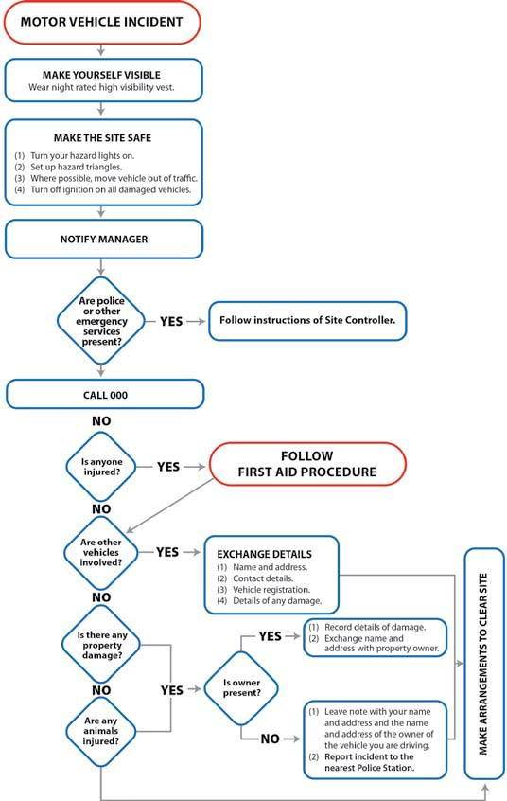

Loss of log on public road
The following flowchart outlines the steps you should take if a log falls off in transit.

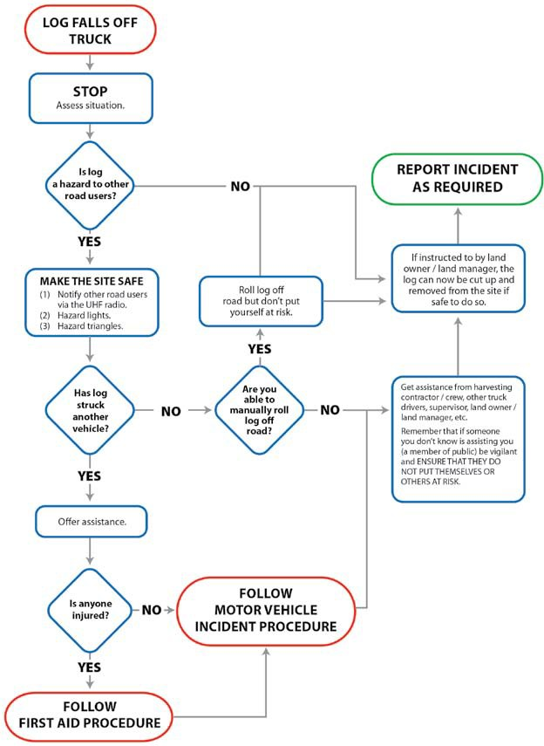

First aid procedure
The following flowchart outlines what to do if you come across an injured person. Make sure you know where to find:
- the phone number to use to call the Emergency Services,
- the name of a first aider, and
- the location of the first aid kit.
Make sure all injuries are reported and the correct paperwork is completed.
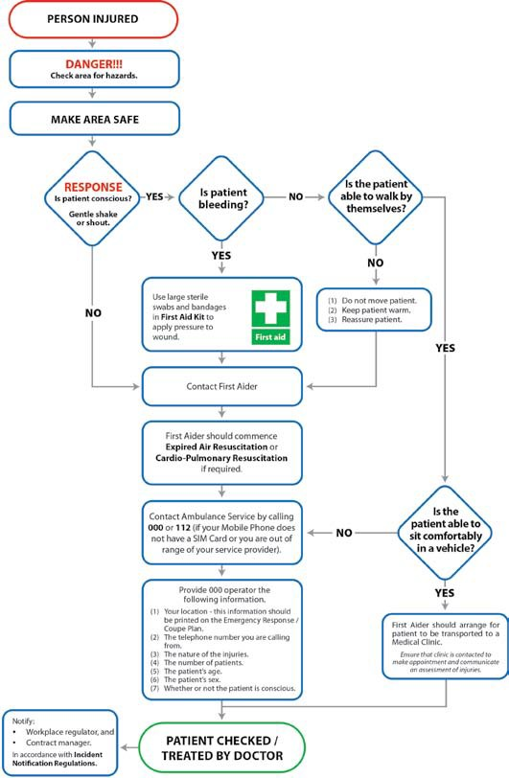

Unauthorised persons entering a worksite
The following flowchart outlines what to do if any unauthorised people enter your worksite. Make sure you know where to find:
- Worksite Supervisor’s name
- land owner / land manager contact details.
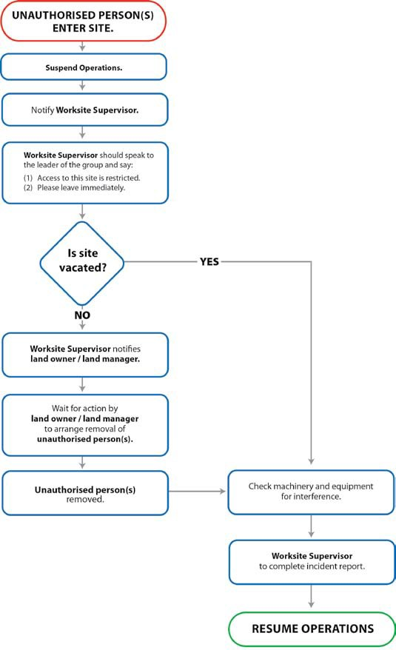

Fire
The following flowchart outlines what to do if a small fire occurs on the roadside or on the forest site. Make sure you know where to find:
- fire extinguishers and other firefighting equipment,
- PPE for fighting fires, and
- safe location.
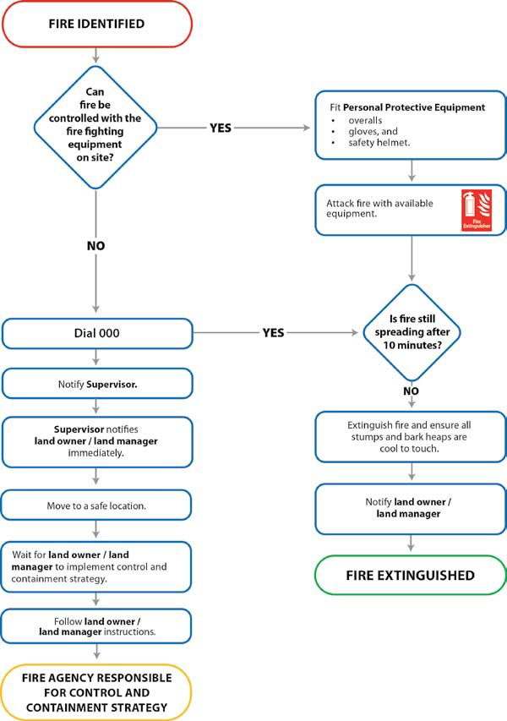

Spills of fuels or oils
The following flowchart outlines what to do if you spill fuel or oil. Make sure you know where to find:
- Material Safety Data Sheets (MSDSs), and
- PPE for handling fuels and oils.
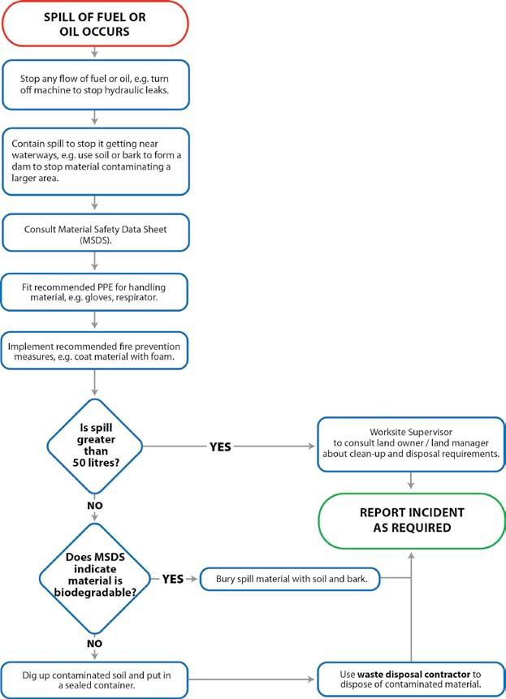

83 | Log Haulage Manual

forestworksISC
FOREST, WOOD, PAPER &TIMBER PRODUCTS INDUSTRY

The Log Haulage Manual is an essential handbook for workers who move logs and other forest produce on trucks from the forest to a processing or export facility.
Log haulage is a risky activity. This manual considers all aspects of log haulage and provides practical guidance to the workers who load trucks, drive trucks and unload them. Many fatalities and serious injuries have occurred as a result of workers being struck by falling logs, trucks rolling over and logs falling off trucks while in transit. As workers need to cooperate as a team when loading and unloading trucks, the manual looks at the responsibilities of different workers to ensure safe work techniques are identified and practised.

The manual is designed as a learning resource to support the national
competency standards for the forest and forest products industry that cover
loading, |  | driving |  |  | and |  | unloading |  | trucks |  | that |  | carry |  | logs |  | and |  | other
forest produce.

A key element to the manual is practical guidance to help forest workers
comply with workplace health and safety laws and the heavy vehicle
national laws. Trees and timber are natural products and as such are less
predictable than other bulk commodities. The manual presents theory,
techniques and tools so that all parties in the value chain, from the forest to
the wood yard, can find solutions to meet their individual requirements.

